
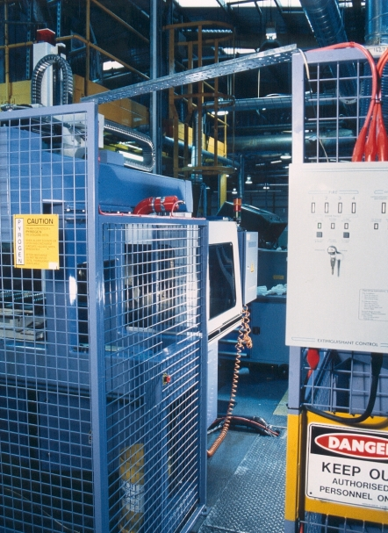
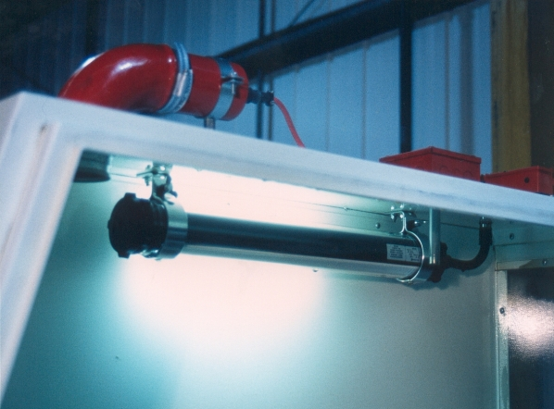
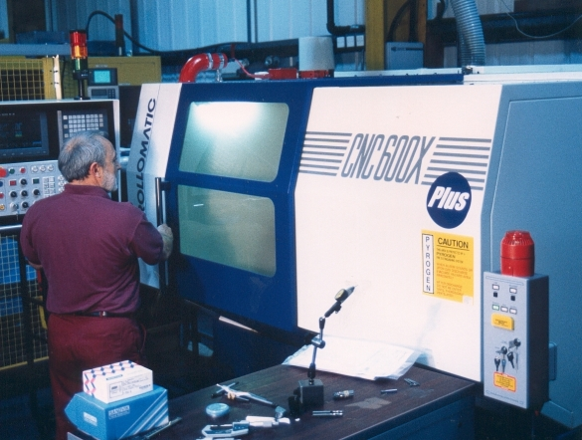
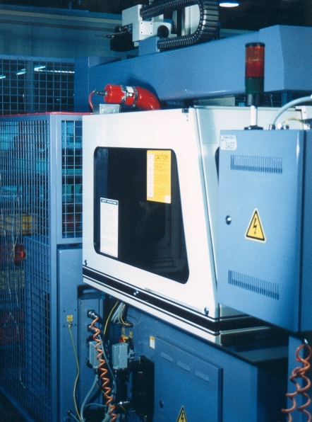
Pyrogen Unit, Detector JB, PyroSense II control unit (foreground) c/w sounder/beacon and Pyrogen warning sign.
Pyrogen unit c/w elbow unit and multi.-zone PyroSense control unit.
Pyrogen unit c/w elbow unit & spigot and Fenwall heat detector probe
CNC Machine – Typical Installations and System Controls

