
Ref: mar1:6-99

Features

- ultra compact and aesthetically pleasing dash mounting control unit

- minimal disruption to boat for installation

- light weight and very compact extinguishing canisters

- 100% environmentally friendly

- minimal maintenance required

- automatic or manual release facility

- meets European standards for marine fire systems

- extensively tried and tested technology and equipment

- available in various sizes to suit all types of boats and vessels

- fully compatible with Pyrogen generators.

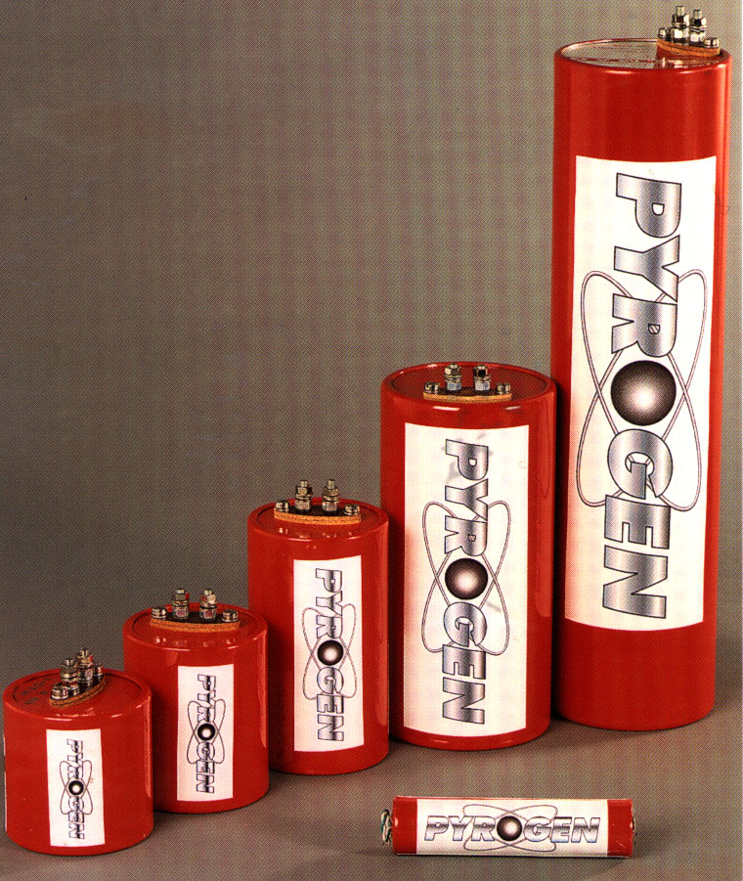
Features
Marine Fire Detection and Suppression Systems
Fire Mermaid systems provide a total solution to protecting boats and small vessels from the high-risk dangers of fire when at sea or in lakes and waterways
A small fire at sea or on a waterway can have serious consequences if it isn’t extinguished immediately. Portable fire extinguishers are well suited for smaller fires in the galley or the accommodation spaces. In the engine bay or room it can be difficult to use a portable unit as it requires that the operator get uncomfortably close to the hot oil fire flames and it may be difficult to get close enough to the source of the fire. With a Pyrogen fixed fire extinguishing system you don’t have to access the engine room or lift a hatch, and thereby increase the fire intensity. All that is needed to extinguish even the most severe engine or bilge fire is to push two buttons. As a failsafe, the Pyrogen fire extinguishing system activates automatically when the sensor cable in the engine area reaches 105ºC.

The heart of the ultra compact Fire Mermaid system is the X2 control panel. The control unit is used for monitoring and activating the compact Pyrogen canister. The control panel is activated by either pressing the two buttons on the front simultaneously or by the sensor cable in the engine room when the temperature exceeds 105ºC.

Fire Mermaid is optimised for use with Pyrogen generators.

