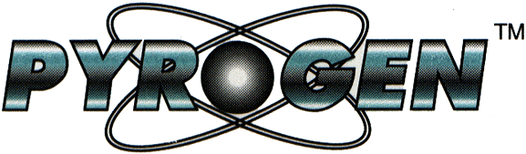

Hong Kong Bus Companies
Pyrogen Aerosol Fire Suppression System
Live Bus Engine
Compartment Fire Test




Test Report

Bus Rear Engine Compartment

Fire Test

Carried out at:

Hong Kong City Bus Workshop
Sha Tin, Kowloon
Hong Kong
January 10th 2000

Test Report Ref.No: PGMal:10-1/00

Pyrogen Corporation Sdn Bhd
No.1, Jalan Mokara 31/62, Kota Kemuning, Section 31, 40640 Sha Alam, Malaysia
Tel: +(60-3) 5219-228. Fax: +(60-3) 5219-226. E-mail: pyrogen@tm.net.my

TEST REPORT ON TESTS CARRIED OUT TO EVALUATE PYROGEN AEROSOL FIRE SUPPRESSION SYSTEMS FOR THE PROTECTION OF
PASSENGER CARRYING BUSSES.

DATE : 10TH. JANUARY, 2000

VENUE : HONG KONG CITY BUS WORKSHOP,
SHA TIN, KOWLOON, HONG KONG

WITNESSED BY:

Hong Kong City Bus Company
Kowloon Motor Bus Company (KMB)

TEST CONDUCTED BY:

Pyrogen Corporation Sdn. Bhd., Malaysia.

1.0 PURPOSE OF TEST

Public transport buses engine fires pose a potentially serious threat to human lives. An effective fire suppression system, installed locally, is deemed the best way to prevent the fires from spreading uncontrollably. Pyrogen’s small canister size was a considered good option as they can be installed at locations hard to access, hence gave the system designer more flexibility in deciding the best configuration for different types of hazard layout.

In most cases, a fire in a bus engine compartment can be predictably assumed to start from a leaked or burst diesel tube supplying fuel to the engine. Fire may spread quickly to engulf the whole compartment area due to a combination of splashed diesel fuel and existing layer of heavy oil on the surface of some components. It is at this stage of intense fire that it need to be contained to prevent it from further spreading to other areas outside the engine compartment.

2.0 TEST ENCLOSURE

The test enclosure consisted of an actual working condition (but no longer utilised for passenger carrying), double-decker bus courtesy of Hong Kong City Bus Company. The engine compartment, measuring 2.15mW x 1.2mH x 0.8mD, with a volume of 2.064m³, was located at the back of the bus. The bottom part of the compartment was opened to the outside environment hence the design of the fire suppression system need to take into consideration huge losses of aerosol.

A viewing window was provided on the engine cover so that the test fires and aerosol discharge could be viewed.

2.1 FIRE SUPPRESSION SYSTEM DESIGN

Two MAG-3 and one MAG-2 Pyrogen generators were used in the test, with MAG-3 and MAG-2 having an aerosol generating compound of 200g and 100g respectively, thus giving a design concentration of 242g/m³.

To give an even distribution of aerosol in the compartment, one MAG-3 generator was mounted at the right side of the compartment, in front of the cooling fan, with the aerosol discharge stream following the direction of the air flow, ie to the left, towards the middle section of the engine block. The second MAG-3 generator was mounted at the back of the compartment, at the top left cornier, pointing towards the right side of the compartment. When discharged the aerosol was expected to shoot towards the right of the compartment, along the back plate and then redirected downwards to the right bottom. A third MAG-2 generator was mounted at the top right, with the nozzle directed downwards towards the bottom left of the engine block. (see figure 1)

The generators were electrically connected in parallel with a fire rated cable and linked to a 24V battery for ignition.

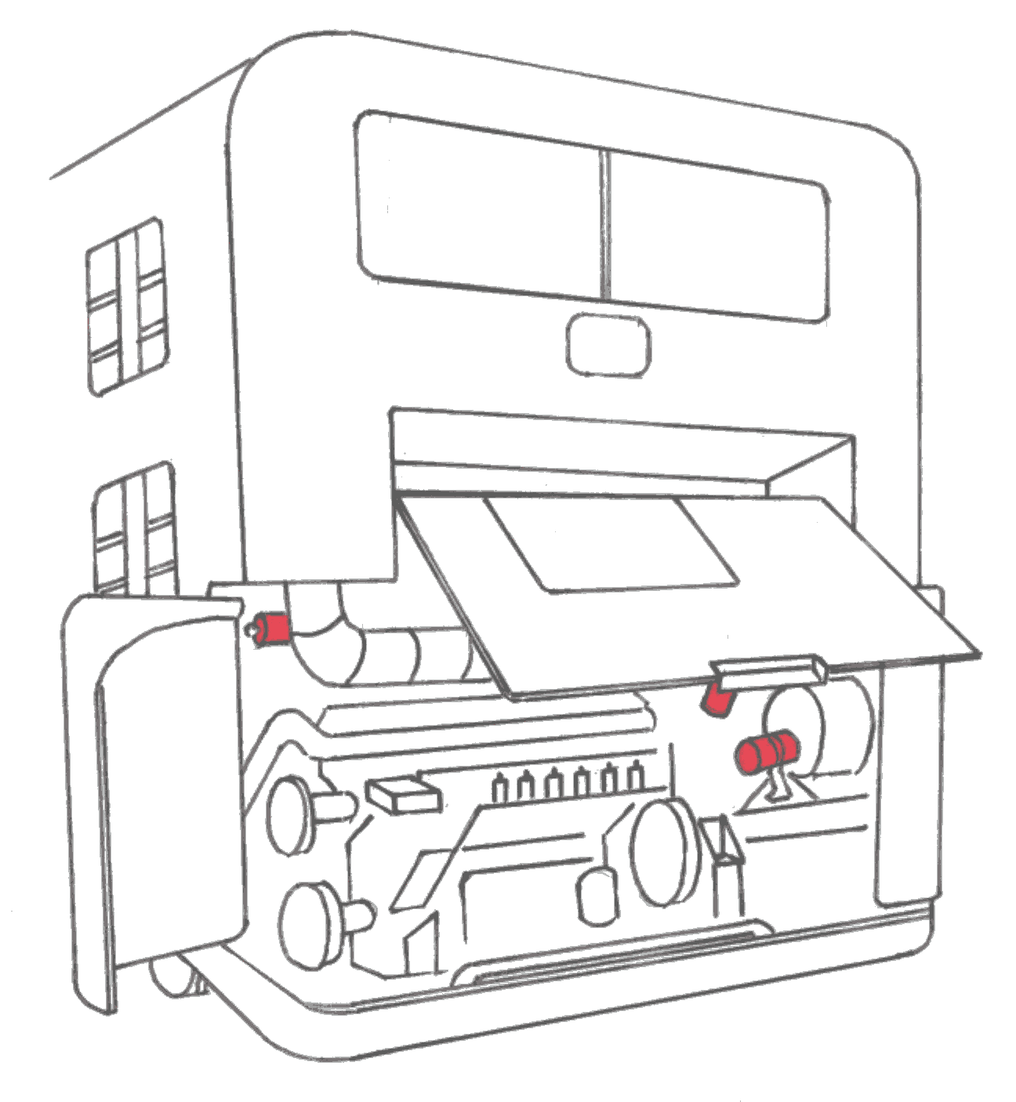

Viewing
Window

MAG-2

MAG-3

MAG-3

Figure 1

2.2 TEST FIRE

The test fires were produced from pieces of cloth soaked with diesel fuel, located at places around the engine block and its surrounding areas. Fires were lighted and a pre-burn time of one minute was allowed before the compartment doors were closed for aerosol discharge. The bus engine was kept running during before the start of fire to warm up the engine before the actual test.

2.3 TEST SEQUENCE

Weather conditions on the day of the test were fine, around 20ºC, with a light breeze.

- Bus engine start-up, let engine run for 30 minutes.
- Stop engine.
- Cloth soaked with diesel were placed around the engine block and its surrounding areas.
- Fires lighted up, pre-burn for one minute.
- Close compartment cover.
- Aerosol discharge.
- After 2 minutes, open cover and observe.

3.0 TEST PHOTOGRAPHS

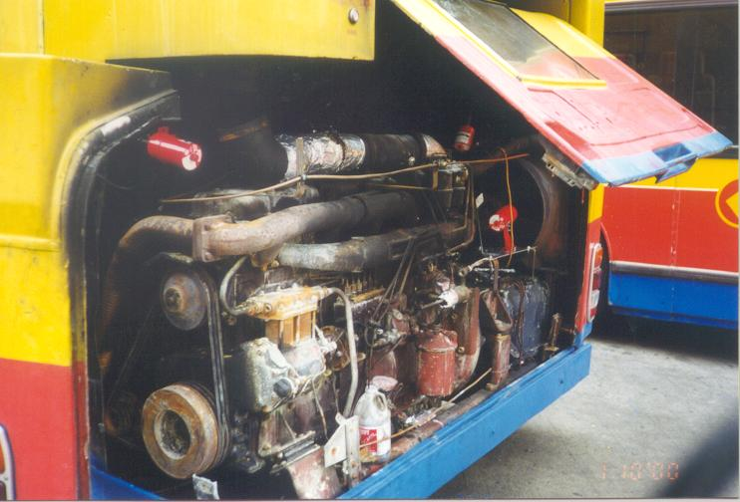

3.1 Layout of Pyrogen Mag Generators prior to test. Note the direction of discharge.

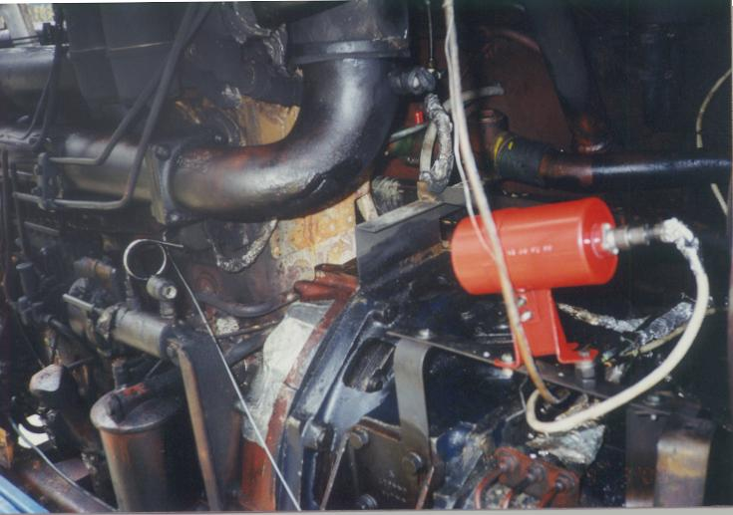

3.2 Layout of Mag 3 Generator at right side of compartment.

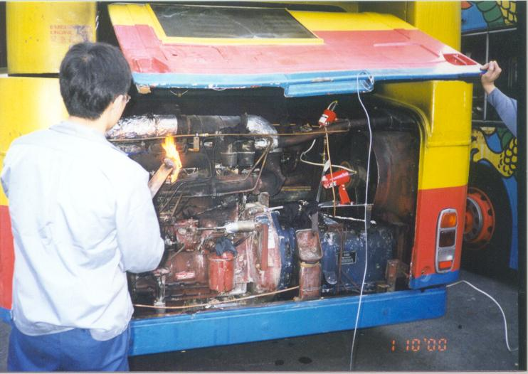

3.3 Preparation for fire start-up.

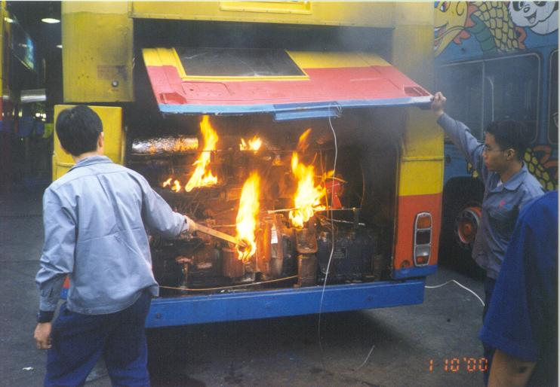

3.4 Engine compartment test fires ignited.

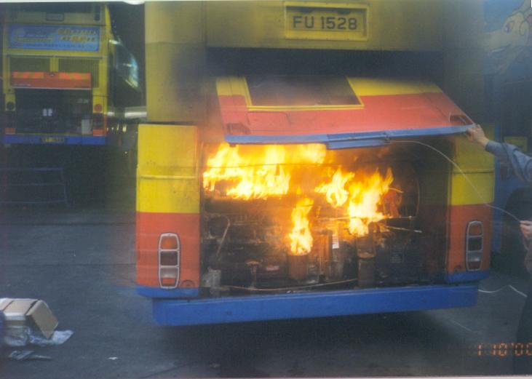

3.5 Test Fire Pre-burn.

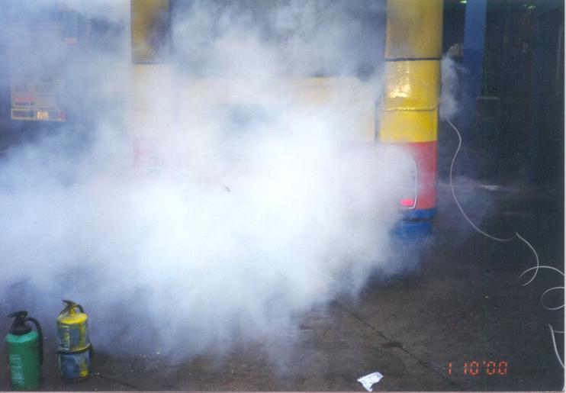

3.6 Aerosol discharged. Note the significant amount of aerosol losses
through unclosble openings.

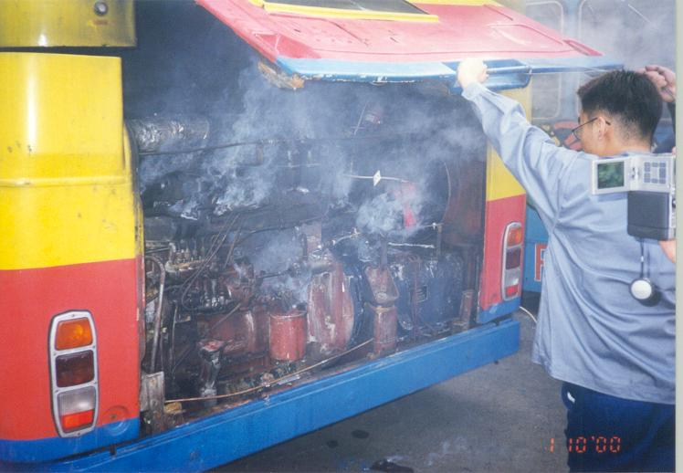

3.7 Rear hatch/door is opened, fires observed to be extinguished.

4.0 TEST RESULT

Following the lighting of the test fires and the one minute ‘pre-burn’ time had elapsed, the Pyrogen aerosol generators were discharged via the introduction of an electrical pulse. The test fires were observed to extinguish in 2/3 seconds and the engine cover was opened 2 minutes later, to confirm the fire extinguishment and generator discharge.

The result showed that the diesel fires were effectively extinguished after the discharge of the aerosol. The aerosol distribution was observed to be evenly distributed, although huge losses were observed to occur through the bottom of the compartment.

All witnesses present reported that they were impressed by the test and compared very favourably against other product testing, which was carried out previously to the same test protocol.

5.0 ANALYSIS AND RECOMMENDATION

This test was performed for one engine configuration only. The arrangement of Pyrogen generators was custom designed and deemed to suit the layout of this particular engine compartment. It is envisage that different types of buses, with different engine configuration and layout, may produce different results than what is expected of the original test. The good distribution of the aerosol, in this critical area of application, is very important. While it is agreed that the system is total flooding, huge losses to the outside environment may pose a challenge to the mechanism to suppress fire during the holding period. To achieve this, while generally applying the system to the various types of buses, the recommendation would be to use more units, mounted to cover all possible blind areas, for example, 2 MAG-3s and 2 MAG-2s combined.

Final detection and extinguishment release designs are yet to be agreed by all parties, but Pyrogen Staff recommend that an automatic linear type detection system be utilised and auto/manual options of Pyrogen Mag unit activation be incorporated.

Report by,

Kok Chen Yang
Executive, Technical Marketing
PYROGEN CORPORATION SDN. BHD.

