NAWCADLKE-MISC-435100-0011

FULL-SCALE AIRCRAFT CABIN
TWIN FLUID, LOW PRESSURE WATER MIST
FIRE SUPPRESSION SYSTEM
PROOF-OF-CONCEPT EVALUATION

FINAL TEST REPORT

16 June 2000

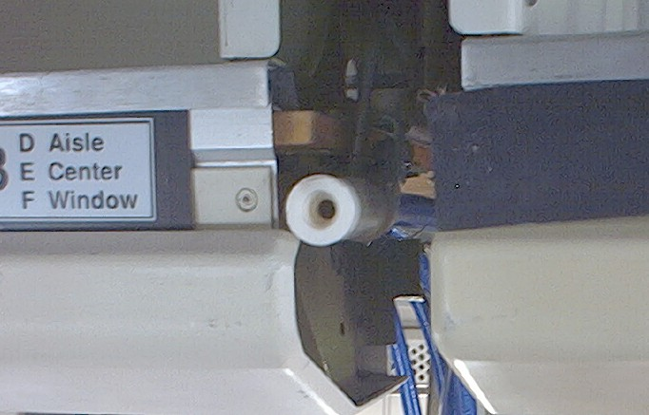
TWIN FLUID, LOW PRESSURE WATER MIST NOZZLE
(Actual installation between two (2) overhead stowage bins.)

DISTRIBUTION AUTHORIZED TO DOD AND DOD CONTRACTORS ONLY; CRITICAL TECHNOLOGY; 16 JUNE 2000. OTHER REQUESTS FOR THIS DOCUMENT SHALL BE REFERRED TO THE COMMANDING OFFICER, NAVAL AIR WARFARE CENTER AIRCRAFT DIVISION, LAKEHURST, NJ 08733-5000.
WARNING - THIS DOCUMENT CONTAINS TECHNICAL DATA WHOSE EXPORT IS RESTRICTED BY THE ARMS EXPORT CONTROL ACT (TITLE 22, U.S.C SEC 2751 ET SEQ.) OR EXECUTIVE ORDER 12470. VIOLATIONS OF THESE EXPORT LAWS ARE SUBJECT TO SEVERE CRIMINAL PENALTIES.

DESTRUCTION NOTICE, FOR UNCLASSIFIED, LIMITED DOCUMENTS, DESTROY BY ANY METHOD THAT WILL PREVENT DISCLOSURE OF CONTENTS OR RECONSTRUCTION OF THE DOCUMENT.

FULL-SCALE AIRCRAFT CABIN
TWIN FLUID, LOW PRESSURE WATER MIST
FIRE SUPPRESSION SYSTEM
PROOF-OF-CONCEPT EVALUATION

PREPARED & REVIEWED BY: _______________________________
JOSEPH WOLFE (Code 435100B)

APPROVED BY: ___________________________________
DOREEN L. BEHMKE (Code 435000B)

TABLE OF CONTENTS

ACKNOWLEDGEMENTS ii
BACKGROUND 1
APPROACH 2
TWIN FLUID, LOW PRESSURE NOZZLE SYSTEM DESCRIPTION 3
INSTRUMENTATION AND DATA ACQUISITION 4
TEST DESCRIPTION 5
Lavatory Fire 5
Galley Fire 6
Seat Cushion Fire 7
Overhead Stowage Bin Fire 8
Ceiling Wire Arc Fire 10
RESULTS 11
CONCLUSIONS 12
RECOMMENDATIONS 13
APPENDIX A 14

ACKNOWLEDGEMENTS

The Naval Air Systems Command (NAVAIRSYSCOM) would like to acknowledge the following team members for their individual efforts in making this a dynamic, successful and safe test series:

- Richard Healing, Director, Office of the Assistant Secretary of the Navy, Installations and Environment, Safety and Survivability, for providing the opportunity to participate in the test series.

- John Brooks, J.D. Gallatin and Bob Verkruysse of International Aero Inc., for providing their in-kind services, capital purchases, tools, equipment and overall expertise of aircraft interiors. Without their support and selfless dedication the Fine Water Mist test series would not have been successful.

- Joel Walker of Quadelta Inc. for providing program and test support both on and offsite.

- Bill Linzey and Vince Press of Lectromechanical Design Company for providing the “arc and spark” for the Ceiling Wire Arc Fire test series.

- Chris Shura of United Airlines for providing technical insight into the test article.

- Richard Cordle of The Memphis Group for providing outstanding onsite support before, during and after the test series.

BACKGROUND

In 1998, the Director for the Office of the Assistant Secretary of the Navy, Installations and Environment, Safety and Survivability (OASN(I&E)(S&S)), established a Government and industry forum, named the Aircraft Wiring and Inert Gas Generator (AWIGG) Working Group, to enhance aviation safety in government and commercial aviation sectors by the sharing of information relative to aircraft wiring threats and options for dealing with in-flight fires. The number of AWIGG participants increased with each meeting, and technologies at various stages of development were continually presented. Technologies introduced to the AWIGG that were identified as potentially viable types of fire suppression systems for use aboard aircraft included water mist and inert gas/aerosol generator technologies. In order to investigate the feasibility of such systems for use in suppressing/extinguishing in-flight fires aboard aircraft, the Director, OASN(I&E)(S&S), pursued an initiative for a combined DoD/Navy and industry proof-of-concept evaluation of these type fire suppression systems.

Through liaison with International Aero Inc., the Office of the Director, OASN(I&E)(S&S), identified The Memphis Group, which has an aircraft salvage facility in Greenwood, MS, as a possible source for an aircraft test platform. Following discussions on the test objectives, The Memphis Group offered an aircraft and onsite support at its Greenwood facility for the DoD/Navy and industry proof-of-concept evaluation. The test article selected was a B-737-200 aircraft, tail number N9022U, that had been removed from service. The Memphis Group also coordinated the requisite airfield/fire fighting support for the evaluation with the Greenwood-LeFlore Airport Manager.

Two (2) water mist systems were identified for evaluation – a high pressure (≈ 1000psi) system developed by the Naval Research Laboratory for the Navy’s new Amphibious Transport Dock, the LPD-17, and a twin fluid, low pressure (≈ 20psi) system developed by the Naval Air Systems Command (NAVAIRSYSCOM), Aircraft Division, Lakehurst, NJ for aircraft applications. The high pressure system setup/evaluation was completed by Naval Research Laboratory, Hughes Associates Inc., and Geo-Centers Inc. personnel. The low pressure system setup/evaluation was executed by the NAVAIRSYSCOM, International Aero Inc., Quadelta Inc., and Lectromechanical Design Company personnel. In addition, NAVAIRSYSCOM, International Aero Inc., Pyrogen Inc., Quadelta Inc., and Lectromechanical Design Company provided the requisite material and technical support for demonstrating the performance of commercially available aerosol generators against realistic in-flight fire threats in aircraft electronics bays and in the passenger compartment overhead area between the ceiling and upper exterior of the fuselage.

The water mist systems and aerosol generator system tests were conducted at The Memphis Group Greenwood-LeFlore Airport facility, near Greenwood, MS, from 1 to 12 May 2000. This report focuses on the twin fluid, low pressure water mist fire suppression system. Results for the high pressure water mist system are provided in a report by the Naval Research Laboratory, and results for the aerosol generator system are provided in a report by NAVAIRSYSCOM, International Aero Inc., Pyrogen Inc., and Quadelta Inc.
APPROACH

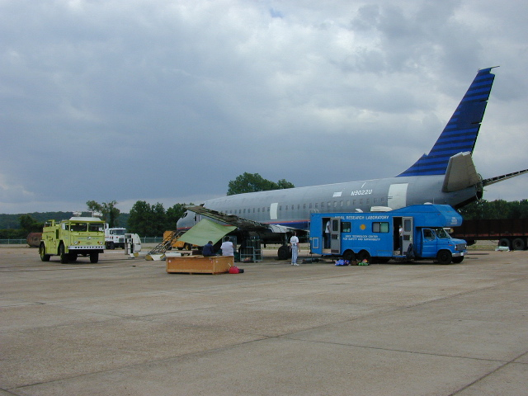
The series of twin fluid, low pressure water mist tests conducted on the Boeing 737-200 aircraft included five (5) individual threats: lavatory fire, galley fire, seat cushion fire, overhead stowage bin luggage fire and ceiling wire arc fire. Before each test for the lavatory, galley, and seat cushion fires, the system was cycled against a 4-inch diameter methanol cup fire to identify any desired refinements to the system setup. Following any final adjustments, each test was conducted in accordance with the respective prescribed scenario. Each test was structured to maximize the realism of the fire threat within the constraints of the test article (reference Figure 1, Test Aircraft and Figure 2, Test Interior), available test equipment and requisite safety precautions. In addition, before and after each test, the aircraft was restored to its original test condition to provide an accurate comparison of tests. For instance, the lavatory was cleaned out of all debris in between tests and swept of excess water to prevent an accumulation on the floor. Also, the seats were covered and the cushions were removed during pre-testing to insure dry conditions for each test.
Figure 1 - Test Aircraft 737-200

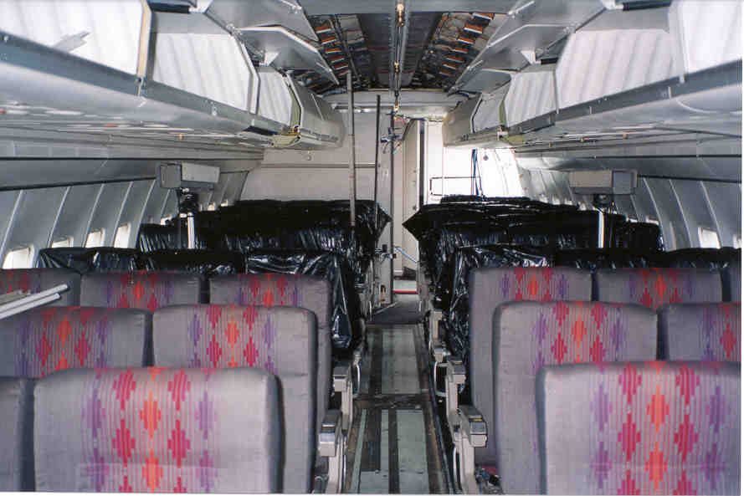

Figure 2 - Test Aircraft Interior

TWIN FLUID, LOW PRESSURE NOZZLE SYSTEM DESCRIPTION

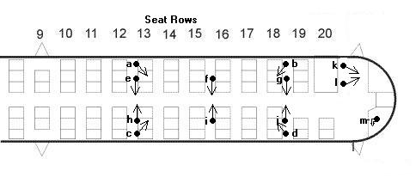
The twin fluid, low pressure water mist nozzle was developed by the NAVAIRSYSCOM Lakehurst, NJ, specifically for aircraft applications. Reliability, fire suppression effectiveness, low maintenance requirements, and low weight were all considered as priority factors during system development. The converging-diverging nozzle design utilizes compressed gas (air or nitrogen) to atomize the water stream, achieving highly effective water mist dispersion with high mist momentum at water and gas pressures of approximately 20psi. The simplicity of the nozzle design (large diameter orifices) ensures high reliability and low maintenance requirements, whereas, the low gas/water pressures required for system performance ensure the overall system weight is far less than weights of water mist systems employing higher pressures. This proof-of-concept evaluation proved that the twin fluid, low pressure system can effectively suppress the types of fires featured in the threat scenarios, with minimal impact on existent aircraft interior configurations and only a nominal increase in overall aircraft weight. Aircraft interior configuration constraints were considered for the location selection and mounting of all twin fluid, low pressure nozzles. No interference with any existing aircraft components or equipment occurred. As graphically represented above in Figure 3, there were a total of 13 twin fluid nozzle locations, ten (10) located on four (4) stowage bins, two (2) in the galley and one (1) in the lavatory; the nozzles were distributed throughout the prototype fire test area as they would likely be positioned for an actual aircraft application. Nozzles a through d were mounted on top and at the rear of the overhead stowage bins directed towards the overhead area of the ceiling for fire protection in the area between the interior ceiling and outer fuselage. Nozzles e through j were mounted in the existing space between, and near the bottom of, the overhead stowage bins directed horizontally towards the center aisle for fire protection in the passenger compartment including the overhead stowage bins. Nozzles k and l were mounted on the forward ceiling in the galley area directed slightly downward and to the rear for galley shelf and floor fire protection. Nozzle m was mounted in the lavatory ceiling aimed directly downward. The twin fluid, low pressure nozzles were manufactured out of light weight heat resistant plastics. Since the pressures used for this system are very low, thin wall plastic or rubber tubing was used for the water lines, and standard PVC piping was used for water distribution. The air lines for the system were standard rubber air hose. Compressed gas for the system was provided by an engine driven air compressor, via a pressure reducing valve. A pressurized water tank was used as the water source. Although these sources would be inappropriate for an actual aircraft installation, they proved satisfactory for the proof-of-concept evaluation.
Figure 3 - Twin Fluid Nozzle Locations

INSTRUMENTATION AND DATA ACQUISITION

Two (2) thermocouple trees were used to measure the gas temperatures in the aircraft. Each tree consisted of seven (7) thermocouples positioned at the following heights above the floor: 0.3, 0.6, 0.9, 1.2, 1.5, 1.8 and 2.1 m (1, 2, 3, 4, 5, 6, and 7 ft). The trees were located in the aisle on the starboard side of the plane. Inconel sheathed type K thermocouples (3.2 mm diameter (Omega Model KMQIN-125G-600)) and Teflon insulated type K thermocouple wire (Omega Model TT-K-24) were used for this application.

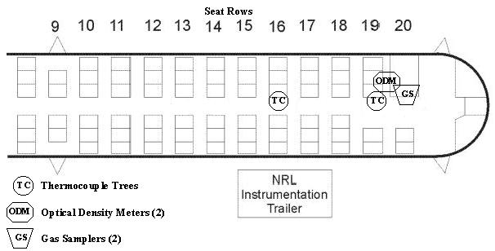
Carbon monoxide, carbon dioxide, and oxygen concentrations were sampled at two (2) elevations in the rear of the aircraft. These concentrations were measured in the aisle adjacent to the aft thermocouple tree. These measurements were taken 0.5 m above the floor and 0.5 m below the ceiling of the aircraft. MSA Lira 3000 Analyzers with a full-scale range of 10 percent by volume were used to measure the carbon monoxide concentrations. MSA Lira 303 Analyzers, with a full-scale range of 25 percent by volume, were used to measure the carbon dioxide concentrations. Rosemont 755 Analyzers, with a full-scale range of 25 percent by volume, were used to measure the oxygen concentrations.

Figure 4 - Instrumentation Location

The reduction in visibility (obscuration) resulting from the smoke and mist was measured at two (2) elevations in the rear of the aircraft. The obscuration was measured in the aisle adjacent to the aft thermocouple tree. These measurements were made 0.5 m above the floor and 0.5 m below the ceiling. The meters were installed with a path length of 0.3 m.

The gas and water pressures for the twin fluid, low pressure system were measured at the air and water distribution manifolds with commercial pressure gauges. Attempts to measure the water flow rate were made using a Flow Technologies, Inc. paddle wheel type flow meter placed in the water line leading from the pressurized water tank, which served as the water source, to the distribution manifold inside the aircraft. However, because the flow meter had a full-scale range of 0-100 lpm (2-26 gpm) and an accuracy of 1.0 percent of the measured value, the measurements were unreliable due to the low flow rates associated with the twin fluid, low pressure system. However, the water flow rates were recorded using the Naval Research Laboratory (NRL) data and noted in the recommendation section of this report.

TEST DESCRIPTION

Lavatory Fire

The lavatory arson fire threat was the first to be tested in the aircraft. A system check was completed using a 4-inch pipe cap filled with methanol. The cap was placed in the middle of the floor and allowed to pre-burn for 15 seconds before mist activation. Data acquisition was incomplete because no water flow rates were recorded. However, the cup fire was extinguished in approximately 1 second when the water mist system was operating properly.

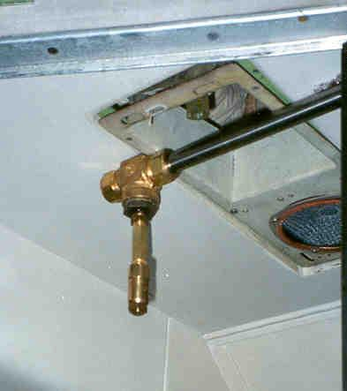
Twin fluid, low pressure nozzle
(note recessed, inconspicuous position)
High pressure system nozzle

Figure 5 - Lavatory Nozzle Locations

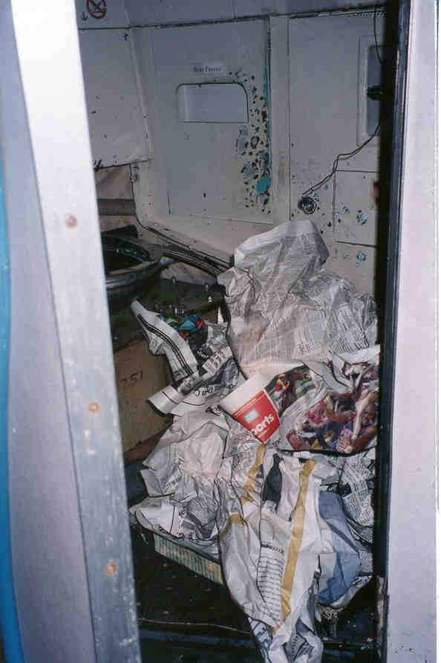
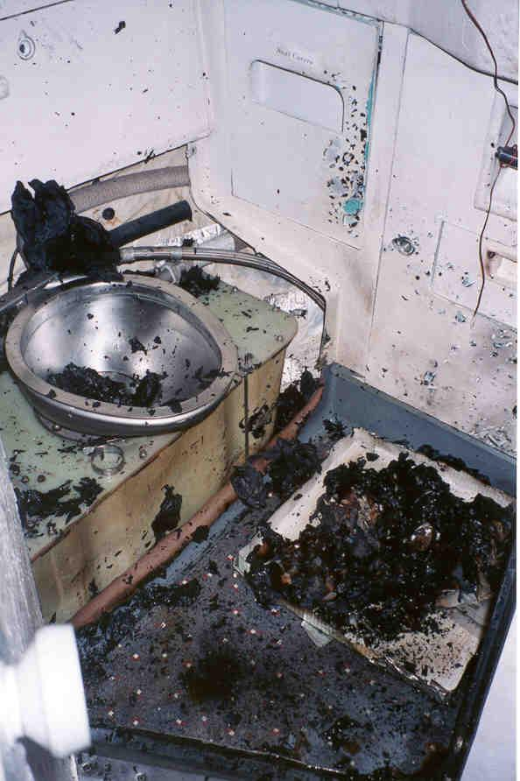
The arson threat consisted of “crumpled” sections of a newspaper piled on the floor (reference Figure 6). Six (6) ounces of acetone was poured over the newspaper and it was then set on fire. There was a 16-second pre-burn time before the mist was activated for AWIGG Test #9. The fire was immediately under control in 1 second and small pieces of newspaper continued to burn until full extinguishment, which occurred after 36 seconds. The flow rate was recorded at 0.64 gpm for a total of 49 ounces or 1.44 liters of water. The heat release is estimated to have been 1,700-2,000 kW initially, as the acetone (estimated from the equation Q=m*ΔH, where Q is heat release, m is burning rate and ΔH is the heat of combustion) burned off. Then at mist activation, a fire output of 100kW, is estimated as the paper was burning along with any remaining acetone. The results are recorded in Table 1 and shown in Figure 7.

Figure 6 - Fire Threat
Figure 7 - Post Test

Galley Fire

As with the lavatory test, system checks were completed for the galley fire using a 4-inch pipe cap filled with methanol. The cap was first placed on the middle of the shelf in the galley and then on the floor. The cup was allowed to pre-burn for 15 seconds before mist activation for each check. Figure 8 illustrates the galley twin fluid low pressure nozzle locations.

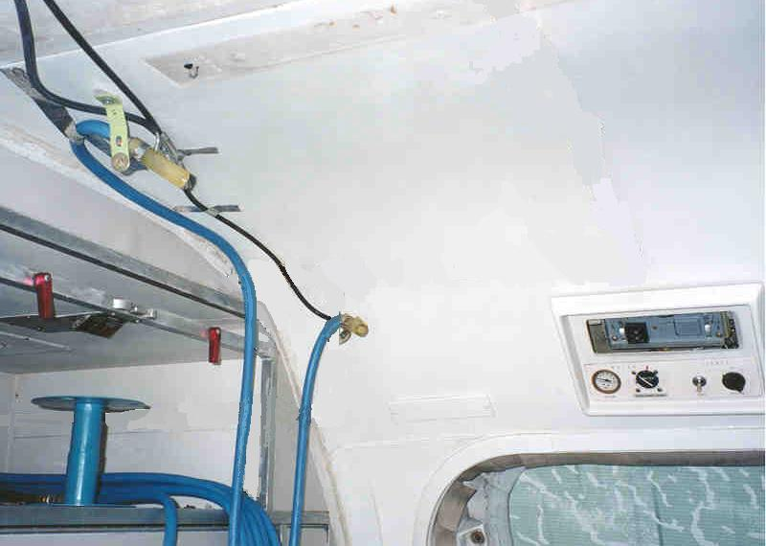
Twin fluid, low pressure nozzles
(mounted on the ceiling next to the forward galley bulkhead, facing down and aft)

Figure 8 - Galley Low Pressure Nozzles

Following the system checks, the galley arson threat scenario was conducted. A plastic trash bag filled with paper napkins, styrofoam cups and plastic cups was used as the fuel for the test. The bag was placed on the floor in the galley area and methanol soaked paper kim-wipes were placed on top of the bag and ignited. The bag was allowed to pre-burn for 15 seconds before mist activation. It is estimated that the heat release at the time of mist activation was approximately 300kW. The fire was controlled immediately; however due to combustion occurring inside the plastic bag, full extinguishment took 3 minutes and 47 seconds. In addition to suppressing/extinguishing the fire, the water mist caused a notable decrease in temperature as detected by the aft thermocouple tree.

Seat Cushion Fire

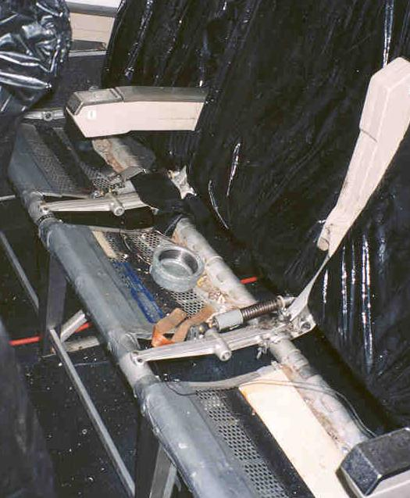

As illustrated in Figure 9, a 4-inch pipe cap with methanol was placed on the center seat and ignited to check the mist distribution throughout the cabin for the seat cushion test series. After the cup fire was successfully extinguished, the arson threat condition was initiated.

Figure 9 - Four-Inch Cap on Seat
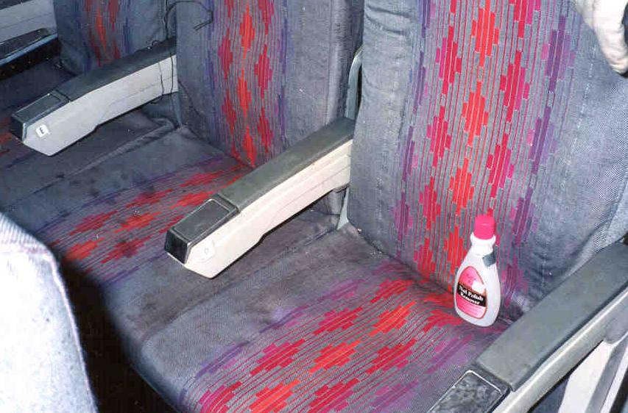
The arson seat cushion test consisted of pouring 6 ounces of acetone on the bottom and back of a center seat (reference Figure 10). The acetone was poured over an approximate area of 0.04 m² for an estimated heat release of 80kW. The acetone was allowed to soak for a short period of time while the fire fighter lit the seat on fire. Pre-burn times of 15 and 30 seconds were tested for AWIGG Tests #23 and #24 where extinguishment times were recorded as 24 seconds and 17 seconds and total water flows were 0.98 gallons (3.71 liters) and 0.59 gallons (2.23 liters) respectively. The results are recorded in Table 1.
Figure 10 - Center Seat Cushion Fire Test

It is important to note that the closest twin fluid nozzle was located across the aisle and one (1) row forward of the fire (reference Figure 11). The twin fluid nozzles were positioned slightly downward from the horizontal for this test series.

Figure 11 - Low Pressure Cabin System Check

Overhead Stowage Bin Fire

For this test series, an overhead stowage bin was removed from the aircraft and set-up outside to determine the amount of time required for the fire to destroy the test article. This was done to determine a fail-safe time constraint for the safety of the fire fighters and the necessary time to abort the test if the mist proved unsuccessful in suppressing the fire. Pictured below in Figure 12 is the stowage bin at the start of the test. The threat consisted of three (3) nylon gym bags filled with miscellaneous clothing articles, a paper gift bag filled with tissue paper, a newspaper, a plastic poncho and methanol soaked kim-wipes placed on top of the center gym bag that were ignited by the fire fighter.

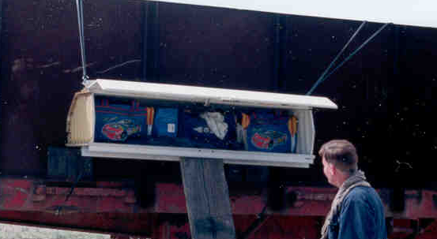
Figure 12 - Overhead Stowage Bin Fire Threat Condition

The results of the fire threat are shown in Figure 13 after 2 minutes of burn time.
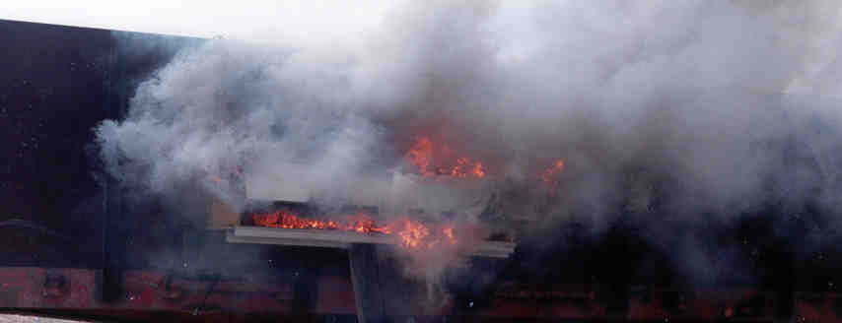
Figure 13 - Overhead Stowage Bin at the 2-Minute Mark
Total damage to the unprotected stowage bin was substantial, as shown below in Figure 14, after the fire was extinguished. As can be seen, almost all of the combustible material was consumed. Although the test team was aware that outside burning rates would differ from those inside the aircraft cabin, it was determined that a 15-second pre-burn would be sufficient.

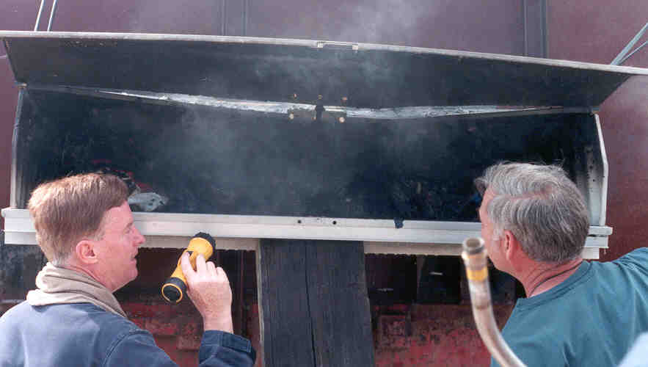

Figure 14 Fire Damage to Stowage Bin after 2-Minute Burn

For this test series, the twin fluid nozzles mounted on the stowage bins were positioned slightly upward from the horizontal. The closest twin fluid nozzle to the stowage bin fire threat was mounted across the aisle and 2.5 feet both forward and aft of the center. Therefore, as in the seat fire threat, no direct path to the fire existed and no nozzles were mounted inside the stowage bins (as in the case of the nine (9) high pressure nozzles mounted in the bins). In this test series, the fire was immediately controlled; however, it was not totally extinguished as it was with the high pressure system. A small flame continued to exist in the center gym bag, the source of the fire. However, if one observes the damage to the stowage bins in each case, as pictured below in Figures 15 and 16, it is evident that there is no noticeable difference in the level of protection provided by the high pressure and twin fluid, low pressure systems.

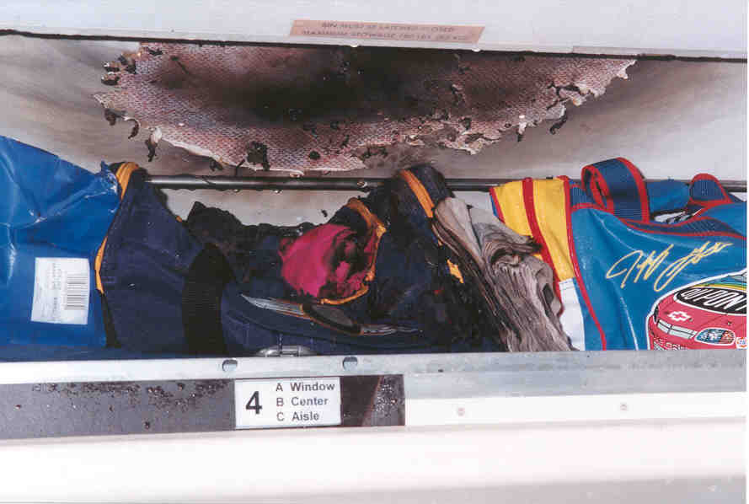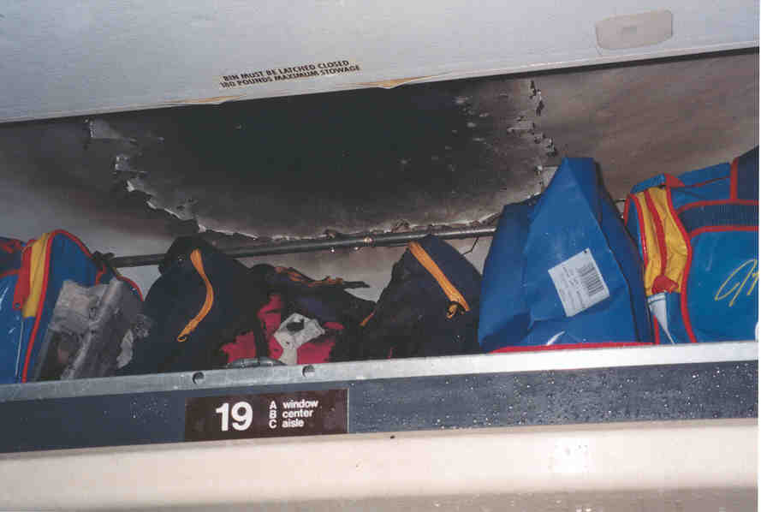

Figure 15 - High Pressure Stow Bin Result Figure 16 - Low Pressure Stow Bin Result

Ceiling Wire Arc Fire

For this test series, the twin fluid, low pressure nozzle system was the only system tested. Ceiling panels were removed and aromatic polyamide wire bundles were taped to the backside of the panel as illustrated in Figures 17 and 18. The panel was replaced in the ceiling and a saltwater drip was used to start the arc while current was flowing through the bundle. For the first attempt at extinguishing the arc, the oscilloscope spike was used to determine when to activate the mist. During this test, AWIGG #28, no large arc was observed prior to mist activation. Only small sparks were present before the mist was activated. After two (2) more attempts (AWIGG Tests #29 and #30) with similar results the decision was made to visually observe the large arc, rather than rely on the current surge indicated by the oscilloscope, to determine when to effect mist activation. Therefore, the bundle used for Test #28 was reused for Test #33 since it was not damaged. For this test, the arc was visually observed before the mist was activated. The water mist kept the wire bundle from breaking apart (from the continuous arcing) by cooling the arc while the wire bundle remained energized. Appendix A contains the Lectromec full report.

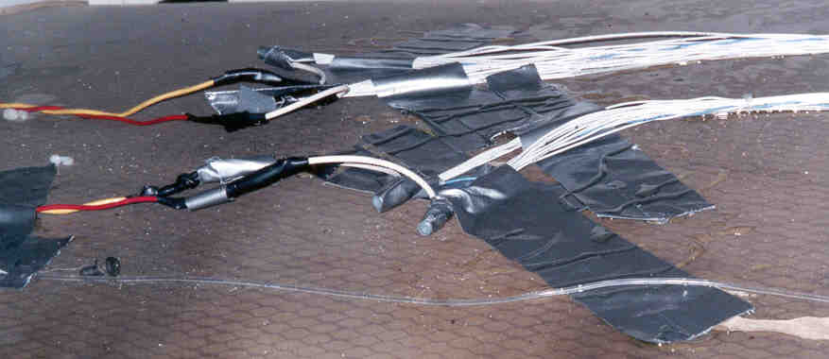
Figure 17 - Wire Bundles on Backside of Ceiling Panels

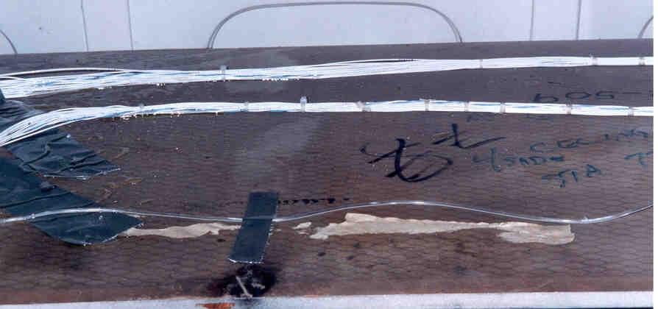

Figure 18 - Wire Bundles with Saline Drip Line on Back of Ceiling Panels

RESULTS

Table 1 - AWIGG Water Mist Test Results Summary

FILE NAME and TEST # | MIST SYSTEM | FIRE LOCATION | FIRE TYPE | EXT TIME | FLOWRATE (gpm) | WATER PRESSURE (psi) | TOTAL WATER FLOW (gallons) | TOTAL WATER FLOW (liters)
AWIGG 01 | HP | LAV | TELL TALE | 0:06 | n/a |  | n/a
AWIGG 02 | TF | LAV | TELL TALE | 1:02 | n/a |  | n/a
AWIGG 03 | TF | LAV | TELL TALE | 2:20 | 0.56 | 20 | n/a
AWIGG 04 | HP | LAV | TELL TALE | 0:05 | 0.85 | 900 | 0.07 | 0.26
AWIGG 05 | HP | LAV | ARSON | 0:08 | 0.85 | 900 | 0.11 | 0.42
AWIGG 06 | TF | LAV | TELL TALE | 0:04 | 0.64 | 22 | 0.04 | 0.15
AWIGG 07 | TF | LAV | ARSON | 0:58 Reign | 0.5 | 20 | n/a
AWIGG 08 | * * * * A B O R T E D * * * * |  |  |  | n/a
AWIGG 09 | TF | LAV | ARSON | 0:36 | 0.64 | 22 | 0.38 | 1.44
AWIGG 10 | TF | GALLEY SHELF | TELL TALE | 2:16 | 0.875 | 20 | n/a
AWIGG 11 | TF | GALLEY FLOOR | TELL TALE | 2:15 | 0.878 | 20 | n/a
AWIGG 12 | HP | GALLEY SHELF | TELL TALE | 0:04 | 2.43 | 880 | 0.16 | 0.61
AWIGG 13 | HP | GALLEY FLOOR | TELL TALE | 0:21 | 2.14 | 850 | 0.75 | 2.84
AWIGG 14 | HP | GALLEY | TRASH BAG | 1:21 | 2.172 | 861 | 2.93 | 11.09
AWIGG 15 | TF | GALLEY FLOOR | TELL TALE | 0:30 | 0.715 | 16 | 0.36 | 1.36
AWIGG 16 | TF | GALLEY | TRASH BAG | 3:47 | 0.714 | 16 | 2.7 | 10.22
AWIGG 17 | HP | SEATS CENTER | TELL TALE | 0:20 | 3.81 | 872 | 1.27 | 4.81
AWIGG 18 | HP | SEATS AISLE | TELL TALE | NO
AWIGG 19 | HP | SEATS 15 SEC | ARSON | 0:05 | 4.149 | 997 | 0.35 | 1.32
AWIGG 20 | HP | SEATS 30 SEC | ARSON | 0:06 | 4.077 | 944 | 0.41 | 1.55
AWIGG 21 | HP | SEATS SLASHED | ARSON | CONTROLLED |  |  | n/a
AWIGG 22 | TF | SEATS CENTER | TELL TALE | 0:22 | 2.023 | 8 | 0.74 | 2.80
AWIGG 23 | TF | SEATS 15 SEC | ARSON | 0:24 | 2.451 | 16 | 0.98 | 3.71
AWIGG 24 | TF | SEATS 30 SEC | ARSON | 0:17 | 2.086 | 8 | 0.59 | 2.23
AWIGG 25 | HP | BIN 15 SEC | LUGGAGE | 1:27 | 1.016 | 902 | 1.47 | 5.56
AWIGG 26 | TF | BIN 15 SEC | LUGGAGE | CONTROLLED | 2.428 | 16 | n/a
AWIGG 27 | HP | SEATS SLASHED | ARSON | CONTROLLED |  |  | n/a
AWIGG 28 | TF | CONCEALED SP | ARC |  | 1.213 | 20 | n/a
AWIGG 29 | TF | CONCEALED SP | ARC |  | 1.215 | 20 | n/a
AWIGG 30 | TF | CONCEALED SP | ARC |  | n/a | 20 | n/a
AWIGG 31 | HP | GALLEY PAPER | ARSON | 0:10 | 4.563 | 810 | 0.76 | 2.88
AWIGG 32 | HP | GALLEY | TRASH BAG | 0:15 | 4.633 | 823 | 1.16 | 4.39
AWIGG 33 | TF | CONCEALED SP | ARC |  | 1.15 | 20 | n/a
AWIGG 34 | HP | BIN 120 SEC | LUGGAGE | CONTROLLED | 1.584 |  | n/a

CONCLUSIONS

The twin fluid, low pressure nozzles proved highly reliable and maintenance free. None of the low pressure system components were damaged during shipment and installation, nor did any damage occur from pre-burn fire, heat, smoke, or wear. In addition, due to their unique design none of the twin fluid nozzles became clogged, unlike the high pressure nozzles, some of which had to be replaced after installation due to clogging.

The installation of the twin fluid, low pressure water mist system can be accomplished with minimal changes to existent aircraft interior configurations. In the passenger compartment, air and water supply lines and nozzles were installed with no change to the overhead stowage bin configuration aside from mounting brackets connected to the exterior of the bins. Nozzles and supply lines in the galley area were mounted/routed on the forward area of the ceiling for demonstration purposes only. In an actual installation, the nozzles and supply lines would be mounted and routed in less conspicuous locations. The nozzle in the lavatory was mounted in a recess in the overhead that could possibly be used in actual installations. The greatest impact in interior configuration would be the installation of the lightweight gas and water supply lines.

The twin fluid, low pressure water mist system proved highly effective in suppressing and extinguishing fires during all threat scenarios. Due to the water droplet size, velocity and dispersion characteristics associated with the twin fluid nozzles, they do not need to be aimed directly at the fire to be effective as in the seat cushion and stowage bin fires where no direct path (line-of-sight) for the nozzles occurred. Even in cases where the fire was not completely extinguished, the twin fluid system controlled the fire, limiting the damage, threat, and temperature increase experienced in the aircraft interior.

The low pressure associated with the twin fluid system accommodates the use of very lightweight and flexible material for gas/water supply lines, and obviates the need for rigid, high pressure metal tubing that not only increases overall weight but also complicates installation/routing.

Upon review of the NRL data for the twin fluid system, it was clear that most data tests were good for flame temperature, operating pressure, and water flow rate. For the lavatory and galley tests, a few tests did exhibit slightly elevated temperatures at the 2.1 meter height on the aft thermocouple tree for obvious reasons. Also, for these tests there was a slight dip in the transmittance for the optical density meter. All other data for the twin fluid nozzle tests are inconclusive, due to the data field being blank, instrumentation not operating correctly, or not registering any noticeable changes.

RECOMMENDATIONS

It is recommended that this test series be repeated with the inclusion of airline industry, Federal Aviation Administration (FAA) and National Transportation Safety Board (NTSB) professionals, and representatives from any other entities that could contribute to a follow-up test program leading to final design and certification of an interior water mist fire suppression system for all passenger and cargo transport aircraft.

It is recommended that subsequent water mist fire suppression systems tests be structured to more accurately reflect the operating parameters that a production system will have to accommodate:

- The operating pressure for any water mist system undergoing evaluation should be cycled from 0psi to its proper operating pressure to more accurately simulate a real system design. Otherwise, test results are subject to notable inaccuracies, due to large pressure changes, because of the displacement of an unrealistically large amount of air as the initial over-pressurized water flow is adjusted down to the reported operating values.

- Subsequent prototype systems should comply with standard aircraft system design specifications to the maximum extent practicable, including conformance to existing aircraft interior configurations.

- In-flight aircraft interior airflow and pressurization should be replicated to the maximum extent possible.

It is recommended that the fidelity of instrumentation used for measuring and recording data be comparable to the ranges of system components used. The water pressure gage and flow meter used for this test series were acquired for recording data associated with the high pressure (1,000-2,000psi) system tested and proved inaccurate for the twin fluid, low pressure (20psi) system.

It is recommended that overall system weight and viability for both retrofit and new construction applications be included in determining the potential applicability for any prototype system that is evaluated.

APPENDIX A

AWIGG 737 Fire Suppression Testing
Greenwood, MS
May 2000

Prepared by:
Lectromec Design Co.
Dulles, Virginia
703-481-1233

Introduction

As part of the Aircraft Wiring and Inert Gas Generator (AWIGG) Working Group’s effort to identify viable fire suppression systems for suppressing/extinguishing in-flight fires aboard passenger and transport type aircraft, the Naval Research Laboratory (NRL) and the Naval Air Systems Command (NAVAIRSYSCOM) conducted proof-of-concept Aircraft Fire Suppression Testing at The Memphis Group’s Facility in Greenwood, Mississippi, in early May of 2000. The testing was conducted onboard a retired Boeing 737-200 aircraft. There were three (3) types of fire suppression systems evaluated: high-pressure water mist, low pressure water mist and Pyrogen aerosol generators. Different types of fuel sources for fires were used, including kerosene, methanol, acetone, paper (and other Class A combustibles), and electrical arcing. Lectromechancial Design Company (Lectromec) supported the NAVAIRSYSCOM effort by providing an electrical arc in wire bundles that were mounted in various zones in the aircraft and, where appropriate, providing instrumentation (i.e., oscilloscope records of arcing events).

This report covers the results of these arcing events as observed by Lectromec personnel. Other observations of these tests by other members of the team have not been integrated into this report (other than a still photo taken from John Brooks' of International Aero, Inc. mpeg video). For a more complete understanding of these tests, this report should be integrated with the data and observations outlined in the test reports on the low pressure water mist and Pyrogen aerosol generator systems of the other team members.

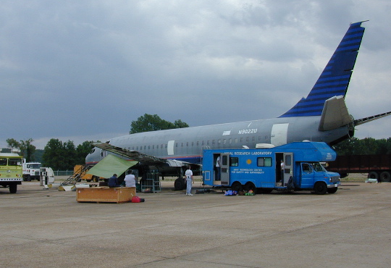
FIGURE 1. AWIGG FIRE SUPPRESSION TEST HELD IN GREENWOOD, MS: BOEING 737
Experimental Detail

The test bundles were constructed using wire that was removed from US Coast Guard helicopters, which were being rewired, and was provided by Joel Walker of Quadelta, Inc. The wire type was MIL-W-81381 of various gauges between 16 and 24.

The bundles were made of 20+ wires 2 to 3 feet long. Approximately one-half of the wires were shorted together to be connected to the high side of the power supply and the other half were shorted together to be connected to the low side of the power supply. In one region of the bundle the insulation of several of the wires (both high side and low side wire) was damaged with a razor such that the conductor was exposed.

The power supply used was a single-phase 60 Hz, 4.5kVA arc welder type generator. This replaced a higher capacity generator that became unavailable due to malfunction.

In the experiments initiated with saline drip, an approximate 1 percent by weight salt solution was used.

Results

TEST #1:

Location: Galley module outside of the aircraft
Initiation: Saline drip on pre-damaged wire
Series Resistance: 1.0 Ohm
Number of Wires/Type: 20+/MIL-W-81381 wires
Mitigation system: None

The test bundle was mounted on the Galley module outside of the aircraft at a ~30-degree angle. There was a period of scintillation and then an arc event. The event lasted 3 to 4 seconds with arc appearing to travel toward the source. Examination of the bundle indicated that the event had, in fact, occurred at the cut end of the sample where the water had flowed before dripping to the ground. The arc appeared to have gone out because it had run into a region where the bundle was tightly wrapped with tape.

TEST #2:

Location: Galley module outside of the aircraft
Initiation: Saline drip/carbon-oil mixture on pre-damaged wire
Series Resistance: 1.0 Ohm
Number of Wires/Type: 20+/MIL-W-81381 wires
Mitigation system: None

Because the bundle used in Test # 1 had not arced in the pre-damaged area, the bundle was reused for this test. In this test, the bundle was hung above a pan of a flammable liquid (kerosene) in an attempt to see if the arc would ignite the liquid. Initially a saline drip was used but the sample had been dipped in kerosene, which is an excellent electrical insulator and water repellant. The arc therefore could not be initiated with the saline drip.

A mixture of graphite powder and 3-in-1 oil was then spread onto the pre-damaged area of the bundle and the sample replaced about 1 inch above the kerosene. When power was applied to the sample, smoke was generated for several minutes and then a full arc was developed. The kerosene in the pan was lit immediately. The arc lasted several seconds before extinguishing.

TEST #3:

Location: EE-Bay
Initiation: Carbon-oil mixture on pre-damaged wire
Series Resistance: 1.0 Ohm
Number of Wires/Type: 20+/MIL-W-81381 wires
Mitigation system: Pyrogen Aerosol Generator

The test bundle was hung vertically in the EE-bay with a pan of flammable liquid underneath it. There were several other pans of flammable liquid placed around the EE-bay. Two (2) of the pans were manually set on fire and left to burn for 60 seconds. The test bundle was then energized. The Carbon-oil mixture on the pre-damaged area, generated smoke and some sparking, but a full arc was not developed. After a few minutes, the generators were set off to extinguish the fire in the pan which was manually started.

TEST #4 (AWIGG Test #28):

Location: Ceiling of main cabin rear
Initiation: Saline drip on pre-damaged wire
Series Resistance: 1.0 Ohm
Number of Wires/Type: 20+/MIL-W-81381 wires
Mitigation system: Low-pressure water mist

In this test, the bundle was mounted horizontally on the topside of a ceiling panel (Figure 2A) in the main cabin. A saline drip onto the damaged area was begun and the bundle energized. There were several minutes of scintillations and flashing (sparking), but a full arc did not develop. Several flashes in a row were interpreted as the beginning of an arc event and the water mist system was triggered. No further flashing was observed for several minutes. It is possible the water mist did prevent the arc from developing as the saline drip normally results in the sequence of: scintillations, flashing and then arcing. The arcing stage did not occur for this sample. Examination of the damaged area revealed little or no further damage caused by the electrical activity.

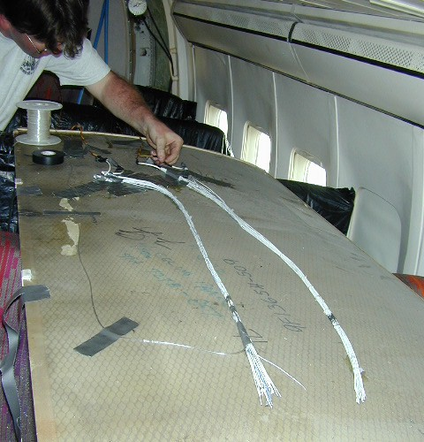
FIGURE 2A: TEST BUNDLES MOUNTED ON CEILING PANEL OF MAIN CABIN PRIOR TO THE
PANEL REPLACEMENT

TEST # 5 (AWIGG Test #29):

Location: Ceiling of main cabin rear
Initiation: Carbon-oil mixture on pre-damaged wire
Series Resistance: 1.0 Ohm
Number of Wires/Type: 20+/MIL-W-81381 wires
Mitigation system: Low-pressure water mist

This wire bundle was mounted parallel to the bundle from TEST #5 on the topside of the cabin ceiling. A carbon-oil mixture on the pre-damaged wire was used for initiation. The current was monitored after the bundle was energized and the water mist triggered when the current began to increase. Unfortunately, a full arc had not developed and did not develop after the mist was deployed. Again, it is difficult to determine if the mist prevented development of the arc.

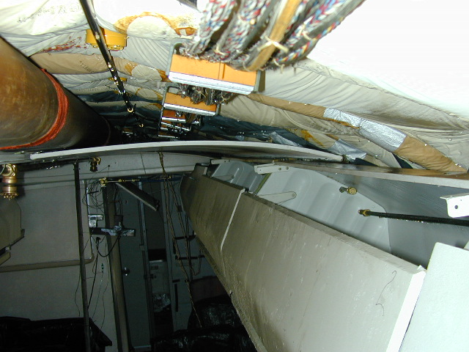
FIGURE 2B: PHOTO OF CEILING PANEL IN MAIN CABIN AFTER REPLACEMENT AND PRIOR TO TESTS

TEST #6 (AWIGG Test #33):

Location: Ceiling of main cabin rear
Initiation: Saline drip on pre-damaged wire
Series Resistance: 1.0 Ohm
Number of Wires/Type: 20+/MIL-W-81381 wires
Mitigation system: Low-pressure water mist

Because the bundle in TEST #4 had not been damaged, it was decided to rerun the test making sure that the arc was well established before triggering the mist. The saline drip was begun and the bundle energized. There was flashing and then a full arc developed. Figure 3 depicts the beginning of the arc with the voltage showing the classic arc flat top waveform and the current reaching 40 amp peaks. Figure 4 depicts the electrical current throughout the arcing event. Between 6 and 7 seconds (5 seconds after the arc began), the arc is extinguished and it appeared that the wires had shorted together producing a sinusoidal current of 20 amperes. The water mist was triggered sometime after the start of the arc, but the affect on the arc is uncertain at this time. The video and oscilloscope recordings can be correlated to shed further light on the situation. Figure 5 shows the damage done to the bundle during the arc event.

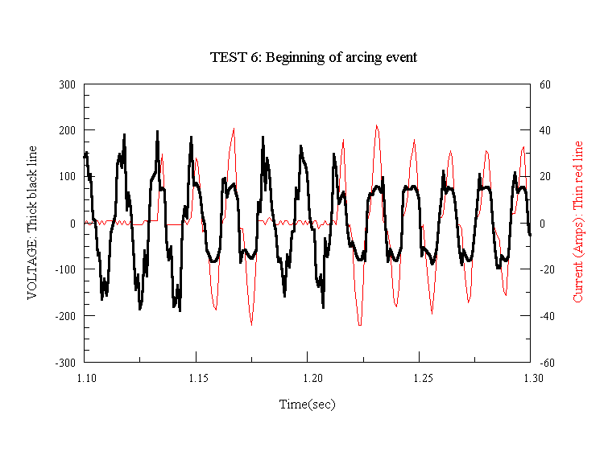
FIGURE 3. TEST #6 (AWIGG TEST #33): VOLTAGE AND CURRENT WAVEFORMS AT THE START
OF THE ARC EVENT
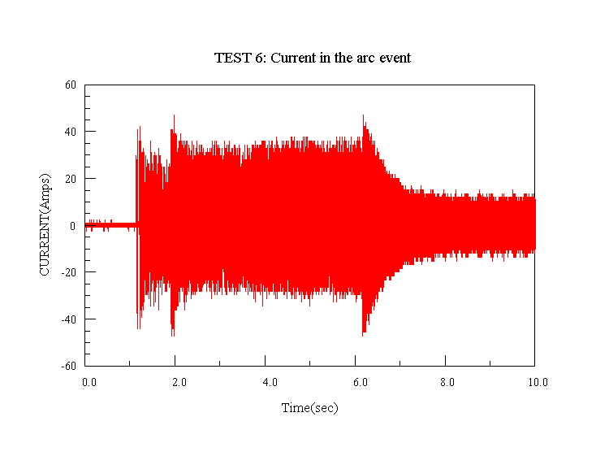
FIGURE 4. TEST #6 (AWIGG TEST #33): CURRENT DURING THE ARCING EVENT

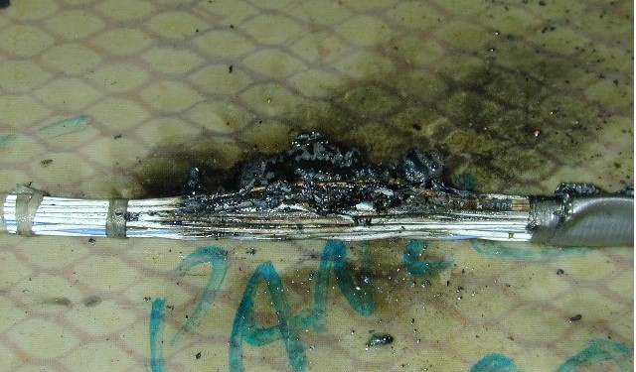
FIGURE 5. TEST #6 (AWIGG TEST #33): DAMAGE DONE TO BUNDLE BY ARCING EVENT

TEST #7:

Location: Galley module outside of the aircraft
Initiation: Saline drip on pre-damaged wire
Series Resistance: 0.5 Ohm
Number of Wires/Type: 20+/MIL-W-81381 wires
Mitigation system: Pyrogen Aerosol Generator

This test was conducted with the sample mounted on the inside of the Galley module that was sealed closed with duct tape (see Figure 6). After the sample was energized, scintillations began and an arc developed. The generator was deployed and the arcing was extinguished. Periodically the sample began to scintillate, sometimes strongly, for several seconds, but a strong arc was not observed.

The oscilloscope recording of the voltage (Figure 8) agrees with the visual observations (the electrical current data file was corrupted and the data could not be recovered). From the shape of the waveform, one can see that the arc began a little after the 85-second mark. The generator was deployed ~85.75 seconds and the arc form changed to one resembling a short circuit by the 86-second mark. Perhaps as the arc extinguished the molten metal solidified, welding two (2) wires together. Further in the oscilloscope record, short periods of electrical activity such as scintillations or flashes were observed, but no strong arcing was evident.

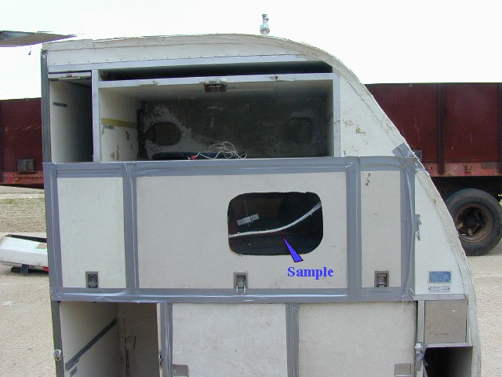
FIGURE 6. TEST #7: SAMPLE MOUNTED IN THE GALLEY PRIOR TO THE TEST
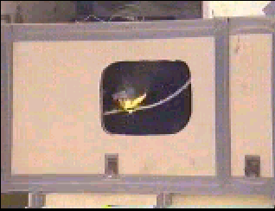
FIGURE 7. TEST #7: INITIAL ARC BEFORE THE GENERATOR WAS DEPLOYED
(CAPTURED FROM MPEG VIDEO)
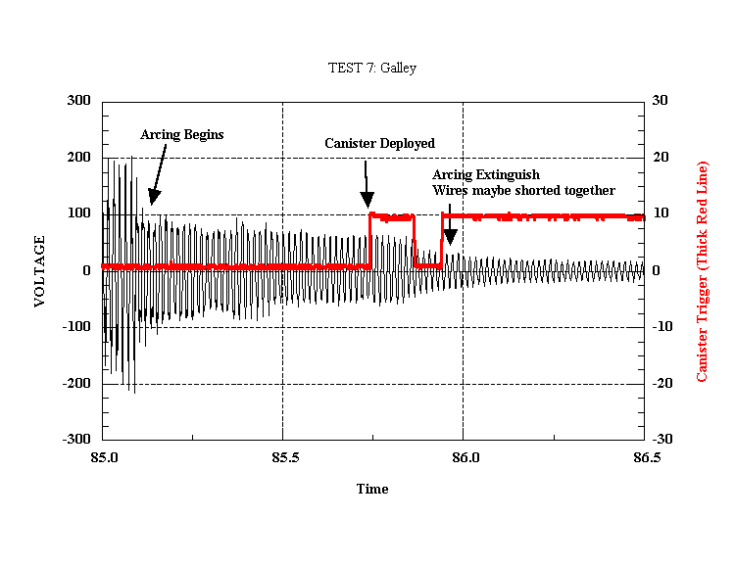
FIGURE 8. TEST #7: VOLTAGE WAVEFORM OF THE INITIAL ARCING EVENT WITH
GENERATOR TRIGGER VOLTAGE ALSO RECORDED

