NAWCADLKE-MISC-435100-0012

FULL-SCALE AIRCRAFT
ELECTRONICS EQUIPMENT BAY
AEROSOL GENERATOR FIRE SUPPRESSION SYSTEM
PROOF-OF-CONCEPT EVALUATION

FINAL TEST REPORT

16 June 2000

Report on Testing of Pyrogen Fire Suppression Aerosol on Boeing 737
Electronics Equipment Bay
On 9 and 10 May 2000

Section Report

DISTRIBUTION AUTHORIZED TO U.S. GOVERNMENT AGENCIES ONLY; CRITICAL TECHNOLOGY; 16 JUNE 2000. OTHER REQUESTS FOR THIS DOCUMENT SHALL BE REFERRED TO THE COMMANDING OFFICER, NAVAL AIR WARFARE CENTER AIRCRAFT DIVISION, LAKEHURST, NJ 08733-5000.
WARNING - THIS DOCUMENT CONTAINS TECHNICAL DATA WHOSE EXPORT IS RESTRICTED BY THE ARMS EXPORT CONTROL ACT (TITLE 22, U.S.C SEC 2751 ET SEQ.) OR EXECUTIVE ORDER 12470. VIOLATIONS OF THESE EXPORT LAWS ARE SUBJECT TO SEVERE CRIMINAL PENALTIES.

DESTRUCTION NOTICE, FOR UNCLASSIFIED, LIMITED DOCUMENTS, DESTROY BY ANY METHOD THAT WILL PREVENT DISCLOSURE OF CONTENTS OR RECONSTRUCTION OF THE DOCUMENT.

FULL-SCALE AIRCRAFT
ELECTRONICS EQUIPMENT BAY
AEROSOL GENERATOR FIRE SUPPRESSION SYSTEM
PROOF-OF-CONCEPT EVALUATION

PREPARED AND REVIEWED BY: ______________________________
JOSEPH WOLFE (Code 435100B)

APPROVED BY: ___________________________________
DOREEN L. BEHMKE (Code 435000B)

TABLE OF CONTENTS

ACKNOWLEDGEMENTS ii

BACKGROUND 1

APPROACH 2

pyrogen aerosol generator system description 3

INSTRUMENTATION AND DATA ACQUISITION 4
Data Aquisition system (DAQ) and Video 4
Fire Equipment Description 4

TEST DESCRIPTION 8
Fire Scenarios 8
Cable Bundle Fire Manual Ignition in the EE-Bay, Test Number I Set Up 9
Polyimide Kapton Arc Fire in the EE-Bay, Test Number II Set Up 10

RESULTS 11
Test Number I 11
Test Number II 11

CONCLUSIONS 15

RECOMMENDATIONS 15

LIST OF FIGURES

1 ENCLOSED AIRCRAFT GALLEY COMPARTMENT 2
2 PYROGEN AEROSOL DISCHARGE IN THE AIRCRAFT'S ELECTRONIC
EQUIPMENT BAY 3
3 CABLE BUNDLES OVER FUEL CUP LOCATED IN THE EE-BAY 5
4 PRE-TEST PICTURE OF CABLE BUNDLES 6
5 PYROGEN MAG-3 GENERATOR WITH UNINTRUSIVE MOUNTING INSIDE
THE EE-BAY 7
6 LAYOUT OF THE PYROGEN AEROSOL GENERATORS INSIDE THE EE-BAY
AND RADOME AREAS 8
7 VIEW OF STARTER FUEL CUP IN THE MIDDLE OF AVIONICS RACK
INSIDE THE EE-BAY 9
8 OXYGEN DEPLETION AND OBSCURATION OF EE-BAY TEST I 11
9 TEMPERATURE READINGS FOR EE-BAY TEST I 12
10 OXYGEN DEPLETION AND OBSCURATION OF EE-BAY TEST II 13
11 TEMPERATURE READINGS FOR EE-BAY TEST II 14

ACKNOWLEDGEMENTS

The Naval Air Systems Command (NAVAIRSYSCOM) would like to acknowledge the following team members for their individual efforts in making this a dynamic, successful and safe test series:

- Richard Healing, Director, Office of the Assistant Secretary of the Navy, Installations and Environment, Safety and Survivability, for providing the opportunity to participate in the test series.
- John Brooks, J.D. Gallatin and Bob Verkruysse of International Aero Inc., for providing their in-kind services, capital purchases, tools, equipment and overall expertise of aircraft interiors.
- K. C. Loh, Richard Lee and Serge Joukov of Pyrogen Corporation, for providing their in-kind services, equipment and expertise of the aerosol generators.
- Joel Walker of Quadelta Inc. for providing program and test support both on and offsite.
- Bill Linzey and Vince Press of Lectromechanical Design Company for providing the “arc and spark” for the test series.
- Chris Schura of United Airlines for providing technical insight into the test article.
- Richard Cordle of The Memphis Group for providing outstanding onsite support before, during and after the test series.

BACKGROUND

In 1998, the Director for the Office of the Assistant Secretary of the Navy, Installations and Environment, Safety and Survivability (OASN(I&E)(S&S)), established a government and industry forum, named the Aircraft Wiring and Inert Gas Generator (AWIGG) Working Group, to enhance aviation safety in government and commercial aviation sectors by the sharing of information relative to aircraft wiring threats and options for dealing with in-flight fires. The number of AWIGG participants increased with each meeting, and technologies at various stages of development were continually presented. Technologies introduced to the AWIGG that were identified as potentially viable types of fire suppression systems for use aboard aircraft included water mist and inert gas/aerosol generator technologies. In order to investigate the feasibility of such systems for use in suppressing/extinguishing in-flight fires aboard aircraft, the Director, OASN(I&E)(S&S), pursued an initiative for a combined DoD/Navy and industry proof-of-concept evaluation of these type fire suppression systems.

Through liaison with International Aero Inc., the office of the Director, OASN(I&E)(S&S), identified The Memphis Group, which has an aircraft salvage facility in Greenwood, MS, as a possible source for an aircraft test platform. Following discussions on the test objectives, The Memphis Group offered an aircraft and onsite support at its Greenwood facility for the DoD/Navy and industry proof-of-concept evaluation. The test article selected was a B-737-200 aircraft, tail number N9022U, that had been removed from service. The Memphis Group also coordinated the requisite airfield/fire fighting support for the evaluation with the Greenwood-LeFlore Airport Manager.

Two water mist systems were identified for evaluation – a high pressure (≈ 1000psi) system developed by the Naval Research Laboratory for the Navy’s new Amphibious Transport Dock, the LPD-17, and a twin fluid, low pressure (≈ 20psi) system developed by the Naval Air Systems Command (NAVAIRSYSCOM), Aircraft Division, Lakehurst, NJ, for aircraft applications. The high pressure system setup/evaluation was completed by Naval Research Laboratory, Hughes Associates Inc., and Geo-Centers Inc. personnel. The low pressure system setup/evaluation was executed by NAVAIRSYSCOM, International Aero Inc., Quadelta Inc. and Lectromechanical Design Company personnel. The water mist systems were tested in the lavatory, galley, and passenger compartment seating area, overhead stowage bins, and overhead area between the ceiling and upper exterior of the fuselage. In addition, NAVAIRSYSCOM, International Aero Inc., Pyrogen Inc., Quadelta Inc. and Lectromechanical Design Company provided the requisite material and technical support for demonstrating the performance of commercially available aerosol generators against realistic in-flight fire threats in aircraft electronics equipment bays.

The water mist systems and aerosol generator system tests were conducted at The Memphis Group Greenwood-LeFlore Airport facility, near Greenwood, MS, 1 – 12 May 2000. This report focuses on the performance of commercially available Pyrogen aerosol generators in suppressing fires in the aircraft electronics equipment bay. Evaluation results for the high pressure water mist system are provided in a report by the Naval Research Laboratory, and results for the twin fluid, low pressure water mist fire suppression system are provided in Navy report number NAWCADLKE-MISC-435100-0011 authored by NAVAIRSYSCOM, International Aero Inc. and Quadelta Inc.

APPROACH

The series of Pyrogen aerosol generator tests conducted on the Boeing 737-200 aircraft included the individual fire scenarios of dipped wire bundles into a flammable fluid placed within the aircraft electronics equipment bay (EE-bay) and steel cup fires placed throughout the EE-bay and radar bay at different heights and locations to monitor the distribution of the aerosol particulate. Before the EE-bay test series, the selected aerosol generator was tested in a modified aircraft enclosed galley compartment (reference Figure 1). The fire conditions tested in the galley compartment consisted of heptane cup fires, wire bundles dipped in heptane over a heptane cup fire and wire arcing cable fire conditions.

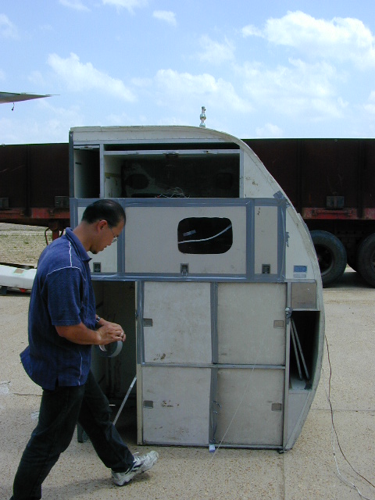

FIGURE 1 – ENCLOSED AIRCRAFT GALLEY COMPARTMENT

The galley test size was approximately one cubic meter, which verified the Pyrogen aerosol distribution throughout the volume since one MAG-3 Pyrogen aerosol generator protects approximately one cubic meter. In addition, the test aided in determining the aerosol’s flow and linger characteristics, and associated obscuration factors. Following any final adjustments, each test was conducted in accordance with the prescribed fire condition scenario. Each test was structured to maximize the realism of the fire threat within the constraints of the test article, available test equipment and requisite safety precautions. In addition, before and after each test, the aircraft galley compartment was restored to its original test condition to provide an accurate comparison between the tests .

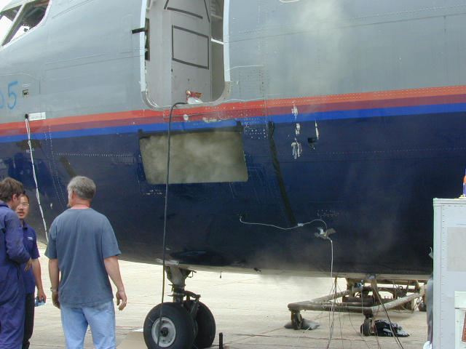

FIGURE 2 – PYROGEN AEROSOL DISCHARGE IN THE AIRCRAFT’S ELECTRONIC EQUIPMENT BAY

PYROGEN AEROSOL GENERATOR SYSTEM DESCRIPTION

After the initial aircraft galley compartment fire tests, the Pyrogen MAG-3 aerosol generator was selected for use in the aircraft’s EE-bay. Using the smaller sized aerosol generators allowed greater flexibility in the positioning of the units thereby ensuring rapid and uniform distribution of the aerosol particulate upon discharge. Figure 2 above illustrates the linger or on-site time of the aerosol particulate inside the aircraft EE-bay and radar bay.

The design concentration of 200 g/m3, a level determined by laboratory testing for electrical fires, was used. Each unit of the Pyrogen MAG-3 provides 200 g of aerosol generating composition.

The empty volume estimated to be 3 cubic meters (m3) in the radar bay section and 9 m3 in the EE-bay section amounted to an estimated total of approximately 12 m3 volume to be protected for this series of aircraft tests. Therefore, 12 Pyrogen aerosol generators were used to enhance the distribution for a total of 2400 grams of aerosol generating composition.

INSTRUMENTATION AND DATA ACQUISITION

Data Acquisition System (DAQ) & Video

Four Type-K thermocouples were used and were located as shown in Figure 3. Thermocouple #1 measured the temperature at the surface of the starter fuel cup, just beneath the cable bundle. Thermocouple #2 was located right in the center of the cable bundle. Thermocouple #3 was placed at the lip of a satellite cup nearest to the electronics equipment bay hatch. Thermocouple #4 was located at the top of the instrument rack located within the electronics equipment bay to record high-level temperatures within the bay. An input into a channel of the DAQ was synchronized with the Pyrogen Discharge Control Box’s activation switch to mark the start of aerosol discharge in the data series. An infrared camera was mounted inside the EE-bay compartment facing the cable bundle fires for both of the EE-bay tests, which provided excellent video documentation and coverage. Rosemont 755 Analyzers, with a full-scale range of 25 percent by volume, were used to measure the oxygen concentration, and the reduction in visibility or obscuration was measured at one location at the top of the avionics rack inside the EE-bay.

Fire Equipment Description

Starter Fuel Cup

- One starter fuel cup for the test cable bundle made of stainless steel with dimensions of 5.9 inch diameter by 5.1 inch high.

- Elevation from floor of instrument bay was equal to 4 inches.

Distance of fuel surface to lip of cup was equal to 1 inch.

- Distance of fuel surface to bottom of cable bundle was equal to 5/8 inch.

- The fuel used was one ounce of kerosene floated on a base of water with a starter of ¼ ounce commercial-grade n-heptane.

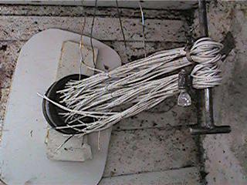

FIGURE 3 – CABLE BUNDLES OVER FUEL CUP LOCATED IN THE EE-BAY

Satellite Cups

- Four satellite fuel cups made of stainless steel with dimensions of 2.7 inches diameter by 3.4 inches high.

- Distance of fuel surface to lip of cup was equal to 0.39 inch.

- The fuel used was 2 ½ ounces of kerosene floated on a base of water with a starter of ¼ ounce commercial-grade n-heptane.

Cable Bundles

Cable bundles from instrumentation cables located on the test B737-200 aircraft were used.

128 polyimide, 20 gauge (AWG), wire segments, 14 inches long, bundled together at the end with wire. This bundle was further divided into 4 sub-bundles, tied in the center, with 32 strands each.

Reference Figure 3 and Figure 4 for pictorial description of the cable bundle set-up.

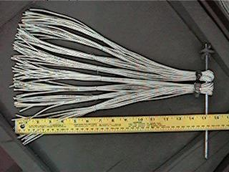

FIGURE 4 – PRE-TEST PICTURE OF CABLE BUNDLES

A handheld butane gas lighter was used for the lighting of the four satellite cup fires inside the EE-bay and the electrical arcing equipment was used to arc the cables above the starter fuel cup.

The Data Acquisition Equipment was a PICO Technologies, 20 Channel Sampling System. Type-K thermocouples were used, and an input signal of the button for the discharge of Pyrogen aerosol into the EE-Bay of B737-200 was recorded. An empty volume, approximately equal to 12 m3 comprised of the radar, ladder and electronics equipment bays, was used for this test series.

12 Pyrogen Fire Suppression Aerosol Generators MAG-3, producing 200g of aerosol generating compound each, were utilized and the mounting arrangement is shown in Figure 6.

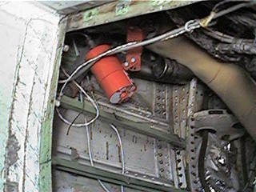

FIGURE 5 – PYROGEN MAG-3 GENERATOR WITH UNINTRUSIVE MOUNTING INSIDE THE EE-BAY

A Pyrogen Discharge Control Box, which contains 12 VDC Sealed Maintenance-free gelled electrolyte batteries and a discharge push button, was used for generator activation.

A wire arcing apparatus was supplied and operated by Bill Lindsey and Vince Press of Lectromechanical Design Company (Lectromec). The equipment included a 112 VAC welder machine, saline drip pump, polyimide cable bundles and a current limiting resistor network board. The system was monitored using an oscilloscope. Detailed information on the Lectromec wire arcing apparatus is included in final report number NAWCADLKE-MISC-435100-0011, titled “Full Scale Aircraft Cabin Twin Fluid, Low Pressure Water Mist Fire Suppression System Proof-of Concept Evaluation.”

TEST DESCRIPTION

Fire Scenarios

Fires in an aircraft EE-bay have been known to occur due to electrical faults from electrical cables with worn insulation or worn connections that resulted in arcing and sparking at the degraded source. The heat energy from the arc and spark events caused secondary fires to occur by igniting insulation or loose debris in the immediate vicinity. Such a degraded wire fire scenario was simulated in this evaluation with fire spread arising from electrical cables that were insulated by normally flame-retardant polyimide type coating and exposed to contamination of petroleum derivatives such as aviation fuel or hydraulic fluid to simulate a possible fuel spill onto an arcing cable bundle. In addition, secondary fires involving a Class B fuel (kerosene) were placed at different locations and heights within the EE-bay to verify the aerosol’s distribution and total-flooding capability.

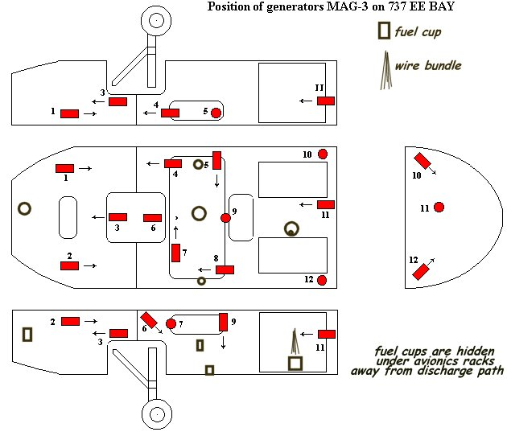

FIGURE 6 – LAYOUT OF THE PYROGEN AEROSOL GENERATORS INSIDE THE EE-BAY AND RADOME AREAS
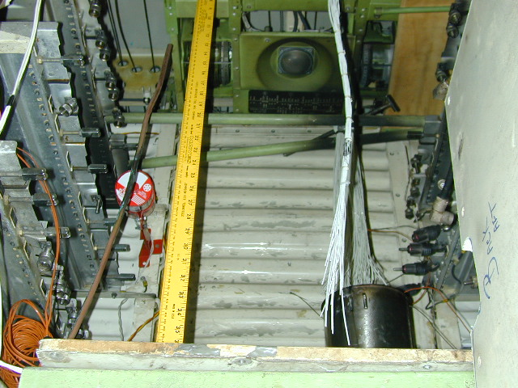

FIGURE 7 – VIEW OF STARTER FUEL CUP IN THE MIDDLE OF AVIONICS RACK INSIDE THE EE-BAY

Cable Bundle Fire Manual Ignition in the EE-Bay, Test Number I Set Up

For EE-bay test number one the 12 Pyrogen MAG-3 aerosol generators were installed with standard kit brackets and were located as indicated in Figure 6. The electrical actuators of all the aerosol generators were wired in parallel and terminated into the Pyrogen Discharge Control Box and synchronized with the Data Acquisition System. The four main openings to the EE-bay were capped-off to simulate the conditions of a sealed fleet aircraft. The underbody access into the radar bay section and electronics equipment bay section were fitted with closeable hatches to allow for access and ignition of the test fire satellite cups and the starter fuel cup with the handheld butane ignitor.

The starter fuel cup, which was filled with water to approximately 1 inch from the top of the cup, was located in the center of the avionics racks, reference Figure 7, at an elevated height of 4 inches from the floor of the EE-bay. The cable bundle was mounted centered and directly above the starter fuel cup, with the distance from the bottom of the cables to the fuel surface being at approximately 5/8 inch. Immediately prior to lighting the starter fuel cup, 1 ounce of kerosene was carefully poured over the cable bundle allowing all excess fuel to drip into the cup. The four satellite cup fires were located as shown in Figure 6 above. Each cup was filled ¾ full with water as a base, and 2 ½ ounces of kerosene were added. The satellite cup fires were ignited first and then the starter cup was ignited and allowed to burn with the cable bundles. The fires were all fully involved before the Pyrogen aerosol generators were discharged.

Polyimide Arc Fire in the EE-Bay, Test Number II Set Up

For EE-bay test number two, 12 new Pyrogen MAG-3 aerosol generators were installed using the existing standard kit brackets and were located as indicated in Figure 6. The electrical actuators of all the aerosol generators were wired in parallel and terminated into the Pyrogen Discharge Control Box and synchronized with the Data Acquisition System. The four main openings to the EE-bay were capped-off to simulate the conditions of a sealed fleet aircraft. The underbody access into the radar bay section and electronics equipment bay section were fitted with closeable hatches to allow for access and ignition of the test fire satellite cups and the starter fuel cup with the handheld butane ignitor.

The starter fuel cup and four satellite cups were all removed and refilled with water to approximately 1 inch from the top of the cup. The starter fuel cup was located in the same spot at the center of the avionics racks, reference Figure 7, at an elevated height of 4 inches from the floor of the EE-bay. The cable bundle was mounted centered and directly above the starter fuel cup, with the distance from the bottom of the cables to the fuel surface being at approximately 5/8 inch. Immediately prior to lighting the starter fuel cup, 1 ounce of kerosene was carefully poured over the cable bundle allowing all excess fuel to drip into the cup. The four satellite cup fires were located as shown in Figure 6 above. Each satellite cup was filled with 2 ½ ounces of kerosene. The cable bundles over the starter cup were energized using the Lectromec arcing device. The cable bundles were perforated and a saline drip was applied to the perforated location approximately 8 to 10 inches away from the starter cup on the bundle. A current was applied to simulate a degraded and energized aircraft cable bundle. The arc caused by this process was enough to ignite the starter cup directly below the cable bundles. The satellite cup fires were ignited first and then the cables were arced above the starter cup for ignition. Again, once ignited, the cables and cups were allowed to burn until the desired temperature was achieved. All fires were fully involved before the Pyrogen aerosol generators were discharged.

RESULTS

TEST NUMBER I

The Data Acquisition System and video recorder were started, the satellite cup in the radar bay section was lit with the butane gas igniter and the underbody hatch closed. The remaining three (3) satellite cup fires in the EE-bay were lit in succession, starting with the cup closest to hatch. After all four (4) satellite cup fires were lit, the cable bundle fire was started by first dousing the cable bundle with 1 ounce of kerosene and allowing all excess to collect into the starter cup. The excess fuel in the cup was ignited with the handheld butane gas lighter. This starter cup ignited the wire bundle in a short period of time. The hatch to the EE-bay was closed and the cable bundle fire was monitored closely via the infrared camera. The Pyrogen discharge button was pressed only after visual confirmation that the cable bundle fire was well involved and the temperature of the cup surface approached 800 degrees C.

FIGURE 8 – OXYGEN DEPLETION AND OBSCURATION OF EE-BAY TEST I

FIGURE 9 – TEMPERATURE READINGS FOR EE-BAY TEST I

The results are displayed in Figures 8 and 9. Due to the low energy flame from the handheld butane lighter, a longer than expected time was taken to light all the satellite cup fires and the cable bundle. This was evidenced by the 225 seconds it took to get all the satellite fires and cable fires started within the electronics bay section. It was noted that the kerosene in the starter cup did not ignite, as verified by the low temperature in the graph of Thermocouple #1. The cable bundle had caught fire and maximum temperature recorded by Thermocouple #3 at the cable bundle just prior to discharge was 320 degrees C. Discharge of Pyrogen aerosol was initiated at t = 465 s. The steep decline of temperature graphs located at Thermocouple #2 and Thermocouple #3, just 2 to 3 seconds following the discharge, illustrates both the efficiency and rapid distribution of the Pyrogen aerosol into the protected volume. Visual inspection of the three satellite cups not monitored with the DAQ’s thermocouples confirmed that flame extinguishment had occurred as a fair amount of fuel had remained in all 3 cups (not measured because of water float). Thermocouple #4, which essentially monitored the temperature directly above the cup, recorded a constant rapid decline in temperature as the flame in the cup was extinguished. Thermocouple #2 recorded the temperature of the cable bundle core and also indicated flame extinguishment. However, due to the slower release of heat energy in the bundled core, the temperature decline was more gradual.

TEST NUMBER II

The polyimide cable bundle was perforated approximately 8 to 10 inches above the starter cup. One quarter ounce of n-heptane was added to the cups immediately prior to lighting with a butane lighter for a more rapid ignition. The DAQ and video recorder were started. The satellite cup in the radar bay section was the first to be lit and the underbody nose wheel access hatch closed. The remaining three satellite cup fires in the electronics bay were lit in succession, starting with the cup closest to the hatch. After the final three satellite cup fires were lit, the cable bundle fire was started by first dousing the cable bundle with 1 ounce of kerosene, allowing the excess to drip into the cup and ¼ ounce of n-heptane was added immediately prior to excitation of the cable bundle using the Lectromec arcing device with saline drip. The hatch to the EE-bay was closed, a current was applied to the cable bundle and the Lectromec saline drip was started. The combination of the current and the saline drip to the perforated section of the cable bundle caused the following chain reaction: first, the saline drip produced an arc on the cable bundle; second, the arc contained sufficient energy to ignite the cable bundles; and last, the cable bundles ignited the starter cup. The cable bundle fire was monitored closely via the infrared camera. The Pyrogen discharge button was pressed only after visual confirmation that the cable bundle fire was well involved and the temperature of the cup surface approached 800 degrees C.

FIGURE 10 - OXYGEN DEPLETION AND OBSCURATION OF EE-BAY TEST II

FIGURE 11 – TEMPERATURE READINGS FOR EE-BAY TEST II

The results are displayed in Figure 11. The use of ¼ ounce n-heptane to start all satellite cup fires resulted in a lower lighting time (only 20 seconds for Test II), which is why the desired temperature was achieved sooner and there was a reduction in total test time. Discharge of Pyrogen was initiated at t = 232 seconds and within 2 seconds, all Class B satellite cup fires were extinguished. Thermocouple #2, located deep within the cable bundle sensed the core temperature of the cable bundle that was not directly exposed to the flame. As in Test I, embers seated deep within the core took longer, an additional 60 seconds, to extinguish. Due to the turbulent mixing of air after discharge, Thermocouple #4, as in Test I, recorded an increase in top level enclosure temperature of 30 degrees C, coming from the mixing of heat from the test fire and the Pyrogen aerosol generators.

CONCLUSIONS

Pyrogen extinguishing action is achieved primarily by interfering chemically with the fire reaction (reference the O₂ plots in Figures 8 and 10). At the reaction temperature the main component of Pyrogen aerosol, potassium compounds, dissociate into potassium radicals. The chemical action of potassium radicals is similar to that of bromine radicals in Halons. Secondarily, extinguishing action is achieved by lowering the fire temperature to a temperature below that of the fire reaction, so that combustion can not be sustained (thermal cooling).

The chemical and physical actions mainly take place on the surface of the aerosol particles. The extremely high surface area of the micron-size aerosol particles increases the likelihood of radical recombination and heat absorbing reactions, thus ensuring rapid extinguishment with a small amount of agent.

The high rate of aerosol discharge ensures a tremendous knock-down effect. Micron- size aerosol particles exhibit gas-like three-dimensional qualities that allow the agent to rapidly distribute throughout the protected area and reach the most concealed and shielded locations. Homogeneous distribution is achieved in a matter of seconds, while long holding times aid in preventing fire re-ignition. As can be seen in Figure 2, the Pyrogen aerosol was vented to empty the EE-bay volume of the aerosol. This clearly illustrates along with the test videos the advantage of the long staying time of the aerosol particulate.

RECOMMENDATIONS

The data from this test series demonstrate that Pyrogen is an extremely efficient fire extinguishing agent, and is a potential replacement for Halon 1301. The lack of reduction of oxygen and lack of high levels of CO/CO₂ in the EE bay illustrate the chemical reaction of the aerosol particles. Further research and testing for additional applications are warranted from this test series.

As a Halon alternative replacement agent, Pyrogen has a wide range of applications. Results from this test series indicate that requirements for compartment flooding applications can be met by Pyrogen for unmanned spaces/areas.

Further research and study should be completed to document any toxicity issues and/or static electricity effects of the Pyrogen aerosol. In addition, further testing on the suspension times of the Pyrogen aerosol for applications involving protected areas that typically experience air flow/exchange should be conducted.

INTERNAL EXTERNAL

Code 435000B SECNAV (10 Copies)
Code 435100B (12 Copies) NAVAIRSYSCOM
Code 313000B:LR (2 Copies) PMA 207 (2 Copies)
NAWCWD China Lake
FAA (2 Copies)
NTSB (2 Copies)
DTIC (2 Copies)

